TRAINWISE: A WEB AND MOBILE-BASED EMPLOYEE TRAINING NEEDS ASSESSMENT AND RECOMMENDATION SYSTEM USING XGBOOST AND NATURAL LANGUAGE PROCESSING

A Capstone Project Presented to the Faculty, College of Computer Studies
Laguna State Polytechnic University
Los Baños Campus
Los Baños, Laguna

In partial fulfillment of the requirement for the degree
Bachelor of Science in Information Technology
Specialized in Web and Mobile Application Development

BRENDERICK I. AMPARO JR.
GIAN CARLO I. MARANAN
KLYDE CISCO T. CANAPI
SEAN JOHN R. LOOC

Alejandro V. Matute Jr.

ACKNOWLEDGMENT

The researchers would like to express their deepest gratitude to everyone who, in one way or another, contributed to the successful completion of this capstone project, TrainWise: A Web and Mobile-Based Employee Training Needs Assessment and Recommendation System Using XGBoost and Natural Language Processing.
First and foremost, to the Almighty God, for the wisdom, strength, and guidance He provided throughout the entire duration of this study. His grace sustained the researchers through the most challenging phases of development, from the conceptualization of the problem down to the final testing of the system.
The researchers extend their sincere appreciation to their adviser, Mr. Alejandro V. Matute Jr., for his invaluable guidance, patience, and constructive feedback. His expertise and constant encouragement pushed the researchers to continuously improve their work and to see this project through to completion.
To the panel of evaluators, for their time, insightful comments, and constructive criticisms that helped refine and strengthen this study.
To the College of Computer Studies and Laguna State Polytechnic University – Los Baños Campus, for providing the knowledge, resources, and environment that made this research possible.
The researchers are also grateful to the Human Resource personnel, department heads, and employees who participated in the surveys, interviews, and system evaluation. Their honest responses and willingness to share their experiences on training needs assessment served as the foundation of this study.
To their families, for their unwavering love, financial support, and understanding throughout the ups and downs of this journey. Their constant encouragement served as a driving force that kept the researchers motivated to finish this project.
To their friends and classmates, for the shared laughter, moral support, and words of encouragement during the most stressful moments of this study.
And finally, to each other — Brenderick, Gian Carlo, Klyde Cisco, and Sean John — for the trust, patience, and teamwork. Despite the disagreements and long nights, the group's unity and shared determination made the completion of this project possible.
To everyone who, in their own little way, extended their help and support — thank you, and this achievement is also yours.

The Researchers

DEDICATION

This capstone project is wholeheartedly dedicated to the researchers' families, who have been their unending source of inspiration, love, and strength. To their parents and guardians, who worked tirelessly to provide for their needs and who never stopped believing in their capabilities even during moments of doubt — this work stands as a testament to their sacrifices.
To their siblings and relatives, who cheered them on and offered a listening ear whenever the pressure of research and development seemed overwhelming.
To the Human Resource practitioners and employees who continuously strive to grow, adapt, and improve despite the demands of the modern workplace — this system was built with you in mind, in the hope that it may, in some small way, make the process of learning and development a little easier.
To future researchers and students of the College of Computer Studies who may find inspiration or reference in this study, may this work serve as a reminder that persistence and collaboration can turn even the most challenging ideas into reality.
And lastly, to God Almighty, the source of all wisdom and strength — this humble work is, above all, dedicated to Him.

CHAPTER I
INTRODUCTION
PROJECT CONTEXT

Individuals have different understandings of success. Success in reality is about the humans that keep moving forward: no matter how big the obstacle is, they continue to strive for what's best in order to better themselves, to be innovative, and to sustain the coming days. The backbone of an institution is basically the employees who work. Their continuous improvements and natural adaptiveness are the key impacts of the production and challenge of the organization.
Because of globalization and the improvement of technology, the industry is evolving, and organizations need to adapt to its fast-paced changes and have a challenger mindset in their own personal sectors. Challenges and problems occur, making the organizations feel pressured, but it is needed so that they are not only ready but also perfectly adapting to evolution and conditioned to meet new obstacles in the way. With the competitiveness of the world, organizations should develop the minds of their employees to gain the success that everyone is yearning for. (Davenport and Ronanki, 2018)
Training is one of the principal ways that organizations promote this type of growth. It builds knowledge, sharpens skills, and outlines employees' career paths. “A good training program prepares workers for the job today and the job tomorrow" (Noe 2020). The problem is that training works when the organization actually knows what its people need. Many companies still find it difficult to figure out which skills are lacking and which type of program will close those gaps. As Noe (2020) explained, training programs only deliver results when they are tied to both organizational goals and the real development needs of employees.
With the training needs assessment of the employees involved, we can say that it is very fundamental to improve, but in the coming years, most of the organization will stay in the traditional ways. In other words, these past methodologies are no longer sufficient for today's organizational demands; they are limited in scope and rely entirely on human judgment rather than systematic data analysis. Some examples include survey questionnaires for employees, one-on-one interviews, reviewing the specific performance of an employee, and the personal suggestions of the higher-ups. Now even after applying these methods to real-life experiences, the issues begin to surface. Most of the time, the results are very inconsistent, and specifically, the analysis is not based entirely on factual data but based merely on one's opinion. With continuous use of these past methods, they always fail to scan those very essential valuable records, especially in those large companies in which the information is so overloaded that it is very hard to keep an eye on every small detail without the use of automated machines.
These weaknesses cause issues for employees and the people who run the training programs. Basically, some employees are not receiving help at all; the reason is that they attend sessions that are really not helpful. This leads to employees not being interested and not improving much. On the other hand, the people in charge have to deal with a lot of data that is hard to go through quickly. This makes it take longer to make decisions and slows down the process. The training programs are not used well. Employees do not get to develop their skills. As a company gets bigger, it becomes harder to manage employee information by hand. The problems with this way of doing things become even clearer. The people who run the company can see that it is not working well, as Salas et al. (2018) noted.
This shows that there is a difference between how companies are handling training now and what they really need to do to help their employees develop. Companies need a system that can do more than just gather information; they need something that can look at the information and figure out what it means and then use that to make something. The problem is not getting the information; it is doing something with the training data. Without the systems, companies have a lot of data from training that they cannot use fully. This underscores the need for organizations to adopt intelligent, technology-driven approaches to training needs assessment, as stated by Provost and Fawcett (2019).
The rapid advancement of technology has fundamentally changed how organizations manage information and support their workforce. Modern institutions have recognized that digital tools are no longer optional but essential for handling large volumes of data, facilitating communication across departments, and enabling faster, more informed decision-making. As Pressman and Maxim (2020) noted, web-based systems are particularly effective in organizational settings because they can accommodate large numbers of concurrent users while remaining accessible across devices and locations, making them well-suited for institution-wide processes such as employee training management.
Alongside web-based platforms, artificial intelligence and machine learning have emerged as powerful tools for transforming raw organizational data into actionable insights. Machine learning enables systems to analyze large datasets, detect patterns, and generate predictions without requiring manual intervention at every step. Among the available algorithms, XGBoost Extreme Gradient Boosting is especially well-regarded for its accuracy and efficiency with structured tabular data. Developed by Chen and Guestrin (2016), XGBoost applies gradient boosting to iteratively correct prediction errors across successive decision trees, resulting in highly reliable classification performance. Zhang and Haghani (2019) further demonstrated its effectiveness in complex, real-world prediction tasks, showing improvements of approximately 15–20% over standard baseline models in multi-class classification scenarios.
However, numerical and structured data alone do not capture the full picture of employee training needs. Employees frequently express their development needs, concerns, and experiences through open-ended survey responses, comments, and self-assessments, forms of unstructured text that cannot be meaningfully quantified through conventional analysis. Natural Language Processing (NLP) addresses this gap by enabling systems to interpret human language, extract meaning from text, and identify patterns that would otherwise go undetected. As Jurafsky and Martin (2023) explained, NLP allows systems to understand not just the words people use, but the deeper communicative intent behind them, making it possible for organizations to gain a more complete and accurate understanding of what their employees actually need.
Despite the availability of these technologies, many organizations have yet to integrate them meaningfully into their training needs assessment processes. Most existing systems are limited to data collection and storage, offering little in the way of intelligent analysis or automated recommendations. As a result, organizations accumulate large volumes of training-related data that remain underutilized, while decision-makers continue to rely on manual review and subjective judgment. Davenport and Ronanki (2018) emphasized that organizations must move beyond passive data collection toward systems that actively analyze information and support evidence-based decisions, a shift that is particularly critical in the context of employee development.
To address these limitations, this study presents TrainWise: a Web and Mobile-Based Employee Training Needs Assessment and Recommendation System using XGBoost and Natural Language Processing. TrainWise integrates data collection, intelligent analysis, and personalized training recommendations into a single platform accessible to both employees and administrators. The system applies XGBoost to analyze structured employee data including department, designation, years of service, and training history to identify competency gaps and predict appropriate training programs. Simultaneously, it uses NLP, specifically Sentence-BERT (SBERT), to process employees' free-text responses and match their expressed training needs with relevant program descriptions based on semantic similarity rather than keyword matching alone.
By combining these two approaches, TrainWise enables organizations to make training decisions that are grounded in actual employee data rather than assumption or informal observation. The system reduces the time and manual effort required to assess training needs at scale, supports administrators with evidence-based reporting, and provides employees with personalized development recommendations aligned with both their individual profiles and organizational goals. As Provost and Fawcett (2019) argued, the organizations that are best positioned to remain competitive are those that transform the data they collect into meaningful, decision-ready intelligence and that is precisely what TrainWise is designed to do.

Objectives of the Study
The general objective of this study is to design a proposed recommendation component based on XGBoost and Natural Language Processing that supports the identification of competency gaps and helps to generate training recommendations grounded in actual data to develop and improve TrainWise, a web-based employee training needs assessment and recommendation system.
To reach this, the study specifically aims to:
- Develop a predictive recommendation model that uses XGBoost and Natural Language Processing (NLP) to go through employee data, surface possible competency gaps, and figure out the appropriate training needs based on both structured and unstructured inputs.
- Design and develop a web-based application by integrating the recommendation model with automated TNA assessment, reporting, and recommendation functions.
- Test and evaluate the existing and enhanced system using the Technology Acceptance Model (TAM) and ISO/IEC 25010 Software Quality Model in terms of usability, functionality, performance efficiency, and user acceptance.

Project Purpose

The purpose of this study is to provide organizations with a more systematic, data-driven approach to identifying the training needs of their employees. In many institutions, training programs are designed and implemented without a thorough understanding of what employees actually need to develop, resulting in misaligned programs, wasted resources, and missed opportunities for professional growth. Traditional training needs assessment methods, which rely on surveys, interviews, and manual evaluation, are often inconsistent and lack the analytical depth required to generate reliable, personalized recommendations at scale. This study addresses that gap by developing and enhancing TrainWise, a web and mobile-based platform that uses XGBoost and Natural Language Processing to automate and improve the training needs assessment process.
TrainWise is designed to identify competency gaps by analyzing both structured employee data such as department, designation, years of service, and training history and unstructured text inputs, such as employees' self-assessments and desired training descriptions. By applying XGBoost to structured records and Sentence-BERT to textual inputs, the system is able to generate personalized training recommendations that are grounded in actual employee data rather than administrative assumptions. This integrated approach replaces time-consuming manual review with an evidence-based, automated process that is both faster and more consistent, supporting administrators and HR personnel in making well-informed training decisions across all departments.
The significance of this study extends to multiple stakeholders. For employees, TrainWise provides a clearer understanding of their strengths and areas for improvement, along with personalized recommendations that support meaningful professional development. For administrators and decision-makers, the system offers structured data, evaluation summaries, and monitoring tools that enable more efficient and objective planning of training programs. For organizations as a whole, TrainWise supports improved workforce competency, reduced training costs, and better alignment between employee development and institutional goals, contributing to long-term organizational sustainability and adaptability in a rapidly changing professional landscape.
This study also aligns with two of the United Nations Sustainable Development Goals. First, it supports SDG 4: Quality Education, which calls for inclusive, equitable, and lifelong learning opportunities for all. By ensuring that employees receive training that is relevant to their actual needs and professional contexts, TrainWise contributes to the goal of continuous, meaningful skill development within the workplace. Second, the study supports SDG 8: Decent Work and Economic Growth, which emphasizes the importance of productive employment and the development of a skilled, adaptable workforce. By improving the efficiency and accuracy of training needs assessment, TrainWise helps organizations build a more competent workforce, one that is better equipped to meet institutional demands, remain competitive, and contribute to sustained economic growth.
Employees. Faculty members and non-teaching personnel will benefit from having a clearer understanding of their strengths and areas for improvement through personalized, data-driven training recommendations. By receiving suggestions that are aligned with their actual competency profiles and professional contexts, employees can focus their development efforts on training programs that are genuinely relevant to their growth and career advancement within the institution.
Administrators and Decision Makers. HR administrators, unit heads, and college deans will benefit from access to organized assessment data, evaluation summaries, and monitoring tools that support more informed and efficient planning of training programs. Rather than relying on manual review or informal observation, decision-makers can use TrainWise to ensure that the training programs they approve and implement are directly aligned with both employee development needs and the broader goals of the organization.
Organizations. Institutions such as Laguna State Polytechnic University will benefit from improved workforce competency, more efficient training management processes, and better overall organizational performance. By integrating intelligent data analysis into their training needs assessment workflows, organizations can respond more effectively to evolving institutional demands and maintain a competitive, well-prepared workforce.
Clients and Stakeholders. Although not direct users of the system, external clients and institutional stakeholders will indirectly benefit from the improved skills and performance of employees who receive more targeted and effective training. Better-trained personnel contribute to higher quality service delivery and stronger institutional outcomes.
Future Researchers. This study can serve as a reference and foundation for future research in intelligent systems, machine learning applications, and recommendation technologies within human resource and training management contexts, particularly studies involving XGBoost, Natural Language Processing, and Sentence-BERT for competency gap analysis and personalized recommendation generation.

The significance of this study lies in its potential to address a persistent gap in how organizations manage employee training and development. By integrating machine learning and natural language processing into a single, accessible platform, TrainWise offers a more systematic and evidence-based alternative to the manual, inconsistent methods that many institutions currently rely on. The system not only streamlines the training needs assessment process but also supports more informed decision-making at every level, from individual employees identifying their own development needs to administrators planning training programs to organizational leaders monitoring workforce competency across departments.
Beyond its immediate institutional application, this study demonstrates that intelligent recommendation technologies can be practically applied in an academic and human resource context, contributing to the growing body of knowledge on data-driven workforce development. TrainWise is significant not simply because it automates a process, but because it transforms how organizations understand and respond to the development needs of their people, making training more relevant, more efficient, and more aligned with long-term organizational goals.

Scope and Limitation of the Study
The study aims at developing and enhancing a web-based employee training needs assessment and recommendation system, called TrainWise, to help organizations identify employee training needs, manage assessment records, monitor evaluation results, and support employee development planning. The present system provides basic functionalities like user registration, profile management, submission of training needs assessment, creation of Individual Development Plan, evaluation, reporting, notification management and document generation.
The system includes an intelligent recommendation engine that uses XGBoost and Sentence-BERT (SBERT) to generate more personalized training recommendations. Structured data such as employee and assessment data is processed using XGBoost, and textual data such as desired training, comments, and other user responses is processed using SBERT. The machine learning component has been implemented and integrated with the existing TrainWise platform. The following are the included modules:
Account Management Module
User Sign Up and Login. This system provides user accounts to select from Faculty Member, Non-Teaching Personnel, Human Resource Administrator and College Dean. Users can log in with their registered credentials to use system features. This module ensures that certain functions are only available to users with the correct role. But new users are subject to approval by the administrator and may be delayed in access.
Profile Management Module
Profile Completeness Post registration, users are required to fill their profiles by providing information such as educational background, specialization, designation, department and years of experience. The system has a profile completion indicator to help users complete required fields. This ensures sufficient information is available for accurate analysis and recommendations. On the contrary, incorrect or missing information may affect the quality of the output of the system.
HR Admin Management Module
User Management and Dashboard. The HR Admin dashboard is the main hub of the system. It displays important information such as total users, submissions, and deadlines. This allows administrators to approve or deny user registration, manage users’ accounts and monitor system activity. This module also includes a deadline setting for training needs assessment submissions. However, the system relies on continuous administrative oversight to keep the data updated and correct.
Assessment and Submission Module
Training Needs Assessment Forms. Users may fill out structured assessment forms by entering training history, attending seminars and desired training programs. The system collects structured data and free-form text input such as comments and suggestions. These data are analyzed to identify competency gaps and training needs. However, the accuracy of results depends on the honesty of the user and the completeness of the information submitted.
Recommendation System Module
Training recommendation. TrainWise has a recommendation section that displays training-related output to the user. This module is connected to a Python-based machine learning recommendation engine that provides personalized training recommendations based on user profile information, submitted training needs assessment data, and desired training inputs.
The recommendation engine uses XGBoost to analyze structured data such as department, role, employee type, assessment responses, and training history. Sentence-BERT (SBERT) is used to process textual inputs and compare the meaning of the user’s desired training with available training program descriptions. Through this integration, the system recommends training programs based on both structured employee information and semantic textual similarity. The recommendation output remains subject to the completeness of the data provided by the user and the training program records available in the system. A recommendation generated by the engine represents a training topic rather than a specific bookable session. When several employees accept the same recommended topic, or independently describe a similar need in their own words, the system pools their interest into a single institutional training demand, which Human Resource personnel then act on. This design reflects a deliberate decision made during development: no fixed catalog of topics can realistically contain a specific, currently scheduled session for every need an employee might describe, so the system's role is to identify and rank which topic is relevant, while locating an actual paid provider, date, and venue is left to the judgment of the college dean or Human Resource personnel.

Training Demand Aggregation and Institutional Sourcing Module. Once enough employees express interest in the same training topic, whether recommended by the system or typed in their own words, the system pools that interest into a single record that Human Resource personnel review. From there, the request is routed to the relevant college dean to locate a real training provider, or, for offices that do not have a dean, handled directly by Human Resource personnel. Once a provider is found, an assistive ranking of interested employees is presented to Human Resource personnel to support their decision on who should attend, taking into account each employee's length of service, prior trainings already completed, and whether their college has previously identified a similar need. Before a confirmed employee's participation may be marked complete, they are required to submit proof of attendance, consisting of a certificate of completion, an approval letter, the event program, and the number of hours attended.
Individual Development Plan (IDP) Module
Creation and Submission of IDP. Users can create and submit Individual Development Plans which identify their goals, competencies and areas for improvement. The system provides an IDP form that users can create, edit and submit as a resource for professional development. These plans can be viewed and tracked by administrators. However, these system-generated plans may not entirely replace expert evaluation and guidance. Evaluation Module (Department-wise)Assessment forms. The system contains evaluation forms administered by department level administrators such as College Deans.

Evaluation Module (By Department)
Evaluation Forms. The system includes evaluation forms managed by department-level administrators such as College Deans. These forms allow evaluators to assess employee performance and training outcomes. The module supports filtering by department, status, and employee type. However, evaluation results may still be influenced by subjective judgment.
Reporting and Monitoring Module
Submission Tracking and Reports. The system allows administrators to track assessment submissions, IDP forms, and evaluation results. It provides filtering and search functionalities for efficient data retrieval. This helps organizations monitor employee progress and training effectiveness. However, reporting is limited to system-generated data and does not include external analytics tools.
General Limitations
The system is a generic solution for organizations and may require adaptations according to the institutional structure and training needs. TrainWise is a web and mobile-based platform and requires stable internet connectivity and basic digital literacy from the users.
The system depends on the accuracy and completeness of the data provided by the user, which directly affects the reliability of the predictions and recommendations. In addition, the system does not support real-time model retraining and it does not have integration with external training platforms, although it uses XGBoost and Sentence-BERT (SBERT).
In addition, the system is designed to assess training needs and recommend training programs, but does not require training participation and does not track long-term employee performance. The current version does not
have advanced features like adaptive learning, AI feedback loops, and external certification integration.

CHAPTER II
THEORETICAL FRAMEWORK OF THE PROJECT

REVIEW OF RELATED LITERATURE, STUDIES, AND SYSTEMS

This chapter presents a review of literature, studies, and existing systems relevant to TrainWise: A Web and Mobile-Based Employee Training Needs Assessment and Recommendation System Using XGBoost and Natural Language Processing. The review covers five key areas that form the theoretical and technical foundation of the study: training needs assessment, machine learning, Natural Language Processing, recommendation systems, and web and mobile platforms. Each area is examined to establish the current state of knowledge, identify the limitations of existing approaches, and justify the need for an integrated, data-driven system such as TrainWise. The review draws on works by Noe (2020), Salas et al. (2018), Chen and Guestrin (2016), Jurafsky and Martin (2023), Reimers and Gurevych (2019), Ricci et al. (2022), Pressman and Maxim (2020), and other relevant authors to situate the study within established research.
MANUAL TRAINING NEEDS ASSESSMENT
Training Needs Assessment (TNA) is a systematic process that organizations use to identify gaps between employees' current competencies and the skills required to meet organizational goals. When conducted effectively, TNA enables institutions to design targeted training programs that address real development needs rather than general or assumed ones. As Noe (2020) emphasized, the success of any training program depends fundamentally on the quality of the needs assessment that precedes it—programs that are not grounded in actual employee data tend to produce limited results regardless of how well they are designed or delivered.
Traditional TNA methods typically rely on surveys, one-on-one interviews, supervisor observations, and manual performance reviews. While these approaches are straightforward to implement, they carry significant limitations. Noe (2020) noted that manual assessment methods are prone to subjectivity, as findings are shaped largely by the perspectives of individual evaluators rather than objective data. Salas et al. (2018) further found that non-standardized evaluation methods produce inconsistency rates of up to 40% in training needs identification, meaning that the same employee population may receive substantially different assessments depending on who conducts the review and how.
These limitations become more pronounced as organizations grow in size and complexity. Managing large volumes of employee records manually is slow, error-prone, and difficult to scale. Integrating different data sources—such as performance evaluations, training histories, and competency assessments—into a single coherent analysis is particularly challenging without automated tools. As a result, important patterns in employee development needs may go undetected, leading to training programs that are misaligned with what employees actually require. Salas et al. (2018) and Noe (2020) both concluded that organizations seeking to improve the accuracy and efficiency of their training decisions must move toward data-driven, automated approaches to training needs assessment.
MACHINE LEARNING
Machine learning is a branch of artificial intelligence that enables systems to learn from data, identify patterns, and generate predictions without being explicitly programmed for each scenario. Unlike rule-based systems that follow fixed instructions, machine learning models improve their performance as they process more data, making them well-suited for complex, large-scale analytical tasks that would be impractical to perform manually. As Provost and Fawcett (2019) explained, machine learning transforms raw data into actionable information by uncovering relationships and trends that are not immediately visible through conventional analysis — a capability that is particularly valuable in organizational environments where data accumulates rapidly across multiple sources.
In the context of employee training, machine learning can analyze structured records such as performance scores, competency assessments, and training histories to identify patterns that indicate where development gaps exist. It can also support predictive analysis, helping organizations anticipate future training needs before gaps become performance problems. By reducing reliance on individual judgment and subjective evaluation, machine learning enables more consistent and scalable decision-making across departments and employee groups.
However, the effectiveness of machine learning depends heavily on the quality and completeness of the data it is trained on. Incomplete or inaccurate records will produce unreliable predictions, and building a well-performing model requires careful data preparation, feature engineering, and hyperparameter tuning. Despite these challenges, machine learning remains one of the most powerful tools available for organizations that need to derive meaningful insights from large and complex datasets — and its application to training needs assessment represents a significant opportunity to improve the precision and relevance of employee development programs.
XGBOOST
XGBoost, or Extreme Gradient Boosting, is a machine learning algorithm widely recognized for its accuracy, computational efficiency, and scalability across a range of prediction and classification tasks. Developed by Chen and Guestrin (2016), XGBoost applies gradient boosting — a technique in which successive decision tree models are trained to correct the errors of their predecessors — to produce a final model that is significantly more accurate than any individual tree. Through regularization techniques and efficient handling of missing values, XGBoost achieves strong predictive performance while reducing the risk of overfitting, making it suitable for real-world datasets that are often incomplete or unevenly distributed.
Chen and Guestrin (2016) demonstrated that XGBoost achieved up to 97.7% classification accuracy on benchmark datasets, outperforming other gradient boosting methods in both speed and prediction quality. Zhang and Haghani (2019) further validated its effectiveness in complex, multi-class classification tasks, reporting accuracy improvements of approximately 15–20% over standard baseline models. These results established XGBoost as a preferred algorithm in data science and machine learning applications where high accuracy and processing efficiency are required simultaneously.
In the context of TrainWise, XGBoost is proposed to analyze structured employee data — including department, designation, specialization, years of service, teaching status, and assessment responses — to identify patterns associated with specific training needs. By processing these features, the model can detect which combinations of employee characteristics are most commonly associated with particular competency gaps, enabling the system to generate training recommendations that are grounded in data patterns rather than subjective evaluation. Effective implementation requires careful data preparation, appropriate feature encoding, and parameter tuning to ensure that the model generalizes well across different employee profiles and departments.
NATURAL LANGUAGE PROCESSING (NLP)
Natural Language Processing (NLP) is a field of artificial intelligence concerned with enabling computers to understand, interpret, and generate human language. In organizational settings, NLP is particularly valuable for analyzing unstructured text data — such as employee survey responses, open-ended assessment answers, and self-reported training preferences — that cannot be meaningfully quantified through numerical analysis alone. As Jurafsky and Martin (2023) explained, NLP allows systems to extract meaning from text by analyzing not just the words used but the intent and context behind them, enabling a deeper and more accurate interpretation of what individuals are communicating.
In training needs assessment, employees frequently describe their development needs in their own words through comments, feedback forms, and open-ended survey questions. This type of qualitative input contains valuable insights that structured questionnaires may fail to capture — insights about specific concerns, preferred learning areas, and self-perceived gaps that are difficult to express through multiple-choice formats. Without automated text analysis, however, this information often goes unprocessed due to the volume and variability of responses. NLP addresses this challenge by systematically analyzing textual inputs, identifying recurring themes, and extracting relevant information that can directly inform training decisions.
Despite its capabilities, NLP is not without limitations. Language is inherently context-dependent and culturally variable, which means that models must be carefully trained on representative data to perform reliably across different communication styles and professional vocabularies. Additionally, NLP systems require regular updates to remain effective as language evolves. When implemented correctly, however, NLP significantly enhances a system's ability to derive actionable insights from unstructured data, making it an essential complement to the structured data analysis provided by algorithms such as XGBoost.
SENTENCE-BERT (SBERT) IN NATURAL LANGUAGE PROCESSING
Sentence-BERT, commonly referred to as SBERT, is a specialized NLP model developed by Reimers and Gurevych (2019) as an extension of the original BERT architecture—Bidirectional Encoder Representations from Transformers. While BERT processes text by analyzing the contextual relationships between individual words in both directions within a sentence, its original design was not optimized for efficiently generating fixed-length representations of entire sentences. SBERT addresses this limitation by using a Siamese network structure to produce sentence-level embeddings—numerical vector representations that capture the overall semantic meaning of a sentence—enabling fast and accurate comparison between different pieces of text.
The primary advantage of SBERT over conventional keyword-matching approaches is its ability to measure semantic similarity rather than surface-level word overlap. When two sentences express the same idea using different vocabulary, SBERT recognizes their similarity based on meaning rather than exact wording. Reimers and Gurevych (2019) demonstrated that SBERT achieved up to 89.6% Spearman correlation on the Semantic Textual Similarity benchmark and operates approximately 80 times faster than standard BERT for similarity tasks—making it practical for real-time recommendation applications.
In TrainWise, SBERT is proposed to process the desired training text submitted by employees and compare it semantically with the descriptions of available training programs stored in the system database. For example, if an employee submits that they wish to improve their skills in protecting organizational data, SBERT can identify training programs related to cybersecurity, information security, or data privacy—even if the employee's exact words do not appear in those program descriptions. This semantic matching capability makes the recommendation process more flexible and contextually aware than keyword-based search, ensuring that employees receive suggestions that genuinely align with their expressed needs rather than only those that happen to share identical terminology.
WEB, MOBILE, AND PROGRESSIVE WEB APPLICATION (PWA) SYSTEMS
Web and mobile platforms have become foundational infrastructure for modern organizational systems, enabling institutions to manage large volumes of data, facilitate communication across departments, and provide users with access to system functions from any location and device. As Pressman and Maxim (2020) noted, web-based systems are especially effective in multi-user organizational environments because they can accommodate concurrent access from many users while maintaining data integrity and system performance—characteristics that are essential for institution-wide processes such as training needs assessment.
Sommerville (2019) further observed that modern software systems benefit significantly from responsive, well-integrated interfaces that allow users to interact with data in real time without performance degradation. In practice, this means that employees can submit assessments, view recommendations, and track their development plans from desktops, laptops, or smartphones through a single web-based platform—eliminating the need for separate device-specific applications. This accessibility is particularly important in institutional settings where users vary widely in their technical proficiency and available devices.
Progressive Web Applications (PWAs) extend the capabilities of standard web platforms by combining web accessibility with mobile-like features such as offline functionality, fast loading, and device-responsive design. Unlike native mobile applications, PWAs do not require installation from an app store and can be updated centrally without user intervention, reducing both development costs and maintenance overhead. While TrainWise is implemented as a responsive web application rather than a full PWA, the responsive design principles underlying PWA development informed the system's interface architecture, ensuring that it functions reliably across a range of screen sizes and browser environments.
RECOMMENDATION SYSTEMS IN TRAINING AND DEVELOPMENT
Recommendation systems are computational tools designed to suggest relevant items or actions to users based on their data, preferences, and behavioral patterns. Originally developed for e-commerce and entertainment platforms, recommendation systems have increasingly been applied to educational and professional development contexts, where they help match learners with resources, courses, or training programs that are most relevant to their individual needs and goals. As Ricci et al. (2022) explained, personalized recommendation systems improve user experience and decision-making efficiency by filtering large sets of options down to a manageable, contextually appropriate selection—a function that is particularly valuable when the number of available training programs exceeds what any individual employee can meaningfully evaluate independently.
In the context of employee development, recommendation systems analyze employee profiles, assessment records, competency evaluations, and expressed preferences to identify which training programs are most likely to address each individual's development gaps. Aggarwal (2019) found that personalized recommendation algorithms improved user engagement by approximately 25% and supported up to 30% gains in decision-making efficiency compared to manual selection processes—demonstrating the practical impact of intelligent recommendations on organizational outcomes.
However, the effectiveness of recommendation systems depends on the quality and completeness of the data on which they operate. Systems that rely on outdated, incomplete, or inaccurate records risk generating irrelevant or misleading suggestions, which can erode user trust and reduce adoption. Additionally, systems that focus solely on generating recommendations without incorporating evaluation and monitoring functions cannot fully support the ongoing development needs of employees. TrainWise addresses these limitations by integrating the recommendation function within a broader platform that also handles assessment submission, evaluation, IDP creation, and administrative reporting — ensuring that recommendations are generated from current, validated data and can be reviewed, tracked, and refined over time.

SYNTHESIS AND RELEVANCE OF THE STUDY
The literature reviewed in this chapter consistently points to a clear and growing need for intelligent, data-driven approaches to employee training needs assessment. Across the works examined, a common pattern emerges: while organizations recognize the importance of identifying and addressing employee competency gaps, the methods they currently rely on are insufficient to meet the demands of modern institutional environments. Manual assessment processes — including surveys, interviews, and supervisor evaluations — are widely documented as inconsistent, time-consuming, and prone to subjective bias (Noe, 2020; Salas et al., 2018). As organizations grow in size and complexity, these limitations become increasingly costly, resulting in misaligned training programs, wasted resources, and missed opportunities for workforce development.
The reviewed literature also demonstrates that the technologies required to address these limitations are well-established and proven. Machine learning, particularly XGBoost, has been shown to deliver accurate and scalable classification performance on structured organizational data, enabling systems to detect patterns in employee profiles and assessment records that would be difficult or impossible to identify through manual review (Chen & Guestrin, 2016; Zhang & Haghani, 2019). Natural Language Processing, and specifically Sentence-BERT, extends this capability to unstructured text by generating semantic embeddings that allow systems to interpret the meaning of employee-submitted responses and match them with relevant training programs — even when exact keywords do not align (Jurafsky & Martin, 2023; Reimers & Gurevych, 2019). Recommendation systems built on these technologies have been shown to improve decision-making efficiency and user engagement significantly compared to manual selection (Ricci et al., 2022; Aggarwal, 2019). Web and mobile platforms, meanwhile, provide the accessibility and scalability needed to deploy such systems across large, multi-role institutional environments (Pressman & Maxim, 2020; Sommerville, 2019).
Despite the availability of these technologies, a significant gap remains between what current systems offer and what institutions such as Laguna State Polytechnic University actually need. Most existing training management systems are limited to data collection and storage, offering little in the way of intelligent analysis or automated recommendation generation. Assessment, analysis, and recommendation functions are often handled by separate, disconnected tools—or not at all—leaving administrators without the integrated decision support required to manage training needs effectively at the departmental and institutional level. This fragmentation is precisely the gap that the reviewed literature identifies as the central barrier to more effective workforce development.
TrainWise directly addresses this gap by combining training needs assessment, intelligent data analysis, and personalized recommendation generation into a single, integrated web and mobile platform. By applying XGBoost to structured employee data and Sentence-BERT to textual training inputs, the system is designed to produce more accurate, relevant, and personalized training recommendations than manual or disconnected approaches can provide. The integration of IDP creation, evaluation, reporting, and notification management within the same platform further ensures that training decisions are supported by complete, current, and role-appropriate data at every stage of the process. In doing so, TrainWise represents a practical application of the technologies and principles documented in the reviewed literature—translating established research findings into a functional system designed specifically for the institutional context of LSPU Los Baños Campus.
Table 1. Technology Gap Analysis Table
Authors | Title | Field | Method / Algorithm | Result
Noe (2020) | Employee Training and Development | Human Resource Development | Manual Training Needs Assessment | Emphasized that accurate training needs assessment improves training effectiveness, but relies on subjective evaluation. Studies indicate that structured TNA improved training effectiveness by approximately 35% over ad hoc approaches, yet the manual process limits scalability.
Salas et al. (2018) | The Science of Training and Development | Organizational Training | Surveys, Interviews, Evaluations | Found that traditional training methods are often inconsistent, time-consuming, and prone to bias. Research suggests up to 40% inconsistency rate in training needs identification when using non-standardized evaluation methods.
Davenport & Ronanki (2018) | Artificial Intelligence for the Real World | Artificial Intelligence | AI-Based Decision Systems | Demonstrated that AI enhances data-driven decision-making and reduces reliance on manual processes. AI-driven systems achieved approximately 45% reduction in manual processing time in organizational decision-support tasks.
Chen & Guestrin (2016) | XGBoost: A Scalable Tree Boosting System | Machine Learning | XGBoost Algorithm | Achieved high accuracy, efficiency, and scalability in predictive modeling tasks. XGBoost reached up to 97.7% classification accuracy on benchmark datasets and outperformed other gradient boosting methods in speed and prediction performance.
Zhang & Haghani (2019) | A Gradient Boosting Method for Prediction | Machine Learning | Boosting Algorithms (XGBoost) | Showed improved classification and prediction performance using large and complex datasets. Gradient boosting improved prediction accuracy by approximately 15–20% over standard baseline models in multi-class classification tasks.
Jurafsky & Martin (2023) | Speech and Language Processing | Natural Language Processing | NLP Techniques (Text Analysis) | Enabled extraction of meaningful insights from unstructured textual data, improving the analysis of human language. NLP-based text classification tasks achieved over 88% accuracy on benchmark language datasets.
Devlin et al. (2019) | BERT: Pre-training of Deep Bidirectional Transformers for Language Understanding | Natural Language Processing | BERT Model | Improved contextual understanding of language through bidirectional processing, enhancing NLP performance. BERT achieved 93.5% accuracy on the GLUE benchmark, outperforming prior NLP methods by up to 7.7 percentage points.
Reimers & Gurevych (2019) | Sentence-BERT: Sentence Embeddings using Siamese BERT-Networks | Natural Language Processing | Sentence-BERT (SBERT) | Enabled fast and accurate semantic similarity comparison, making it suitable for recommendation and matching systems. SBERT achieved up to 89.6% Spearman correlation on the STS benchmark and is approximately 80x faster than standard BERT for similarity tasks.
Ricci et al. (2022) | Recommender Systems Handbook | Recommendation Systems | Collaborative & Content-Based Filtering | Improved personalization and user experience through tailored recommendations. Collaborative filtering methods improved recommendation precision by 20–30% compared to non-personalized systems across multiple evaluation benchmarks.
Aggarwal (2019) | Recommender Systems: The Textbook | Data Mining | Recommendation Algorithms | Increased user engagement and supported more efficient decision-making. Recommendation algorithms demonstrated approximately 25% improvement in user engagement and up to 30% gain in decision-making efficiency over manual selection.

CONCEPTUAL FRAMEWORK
The conceptual framework of this study illustrates how TrainWise: A Web and Mobile-Based Employee Training Needs Assessment and Recommendation System using XGBoost and Natural Language Processing operates as a system that draws from its institutional environment and its accumulated knowledge to produce reliable, evidence based outcomes that support training and development within Laguna State Polytechnic University.

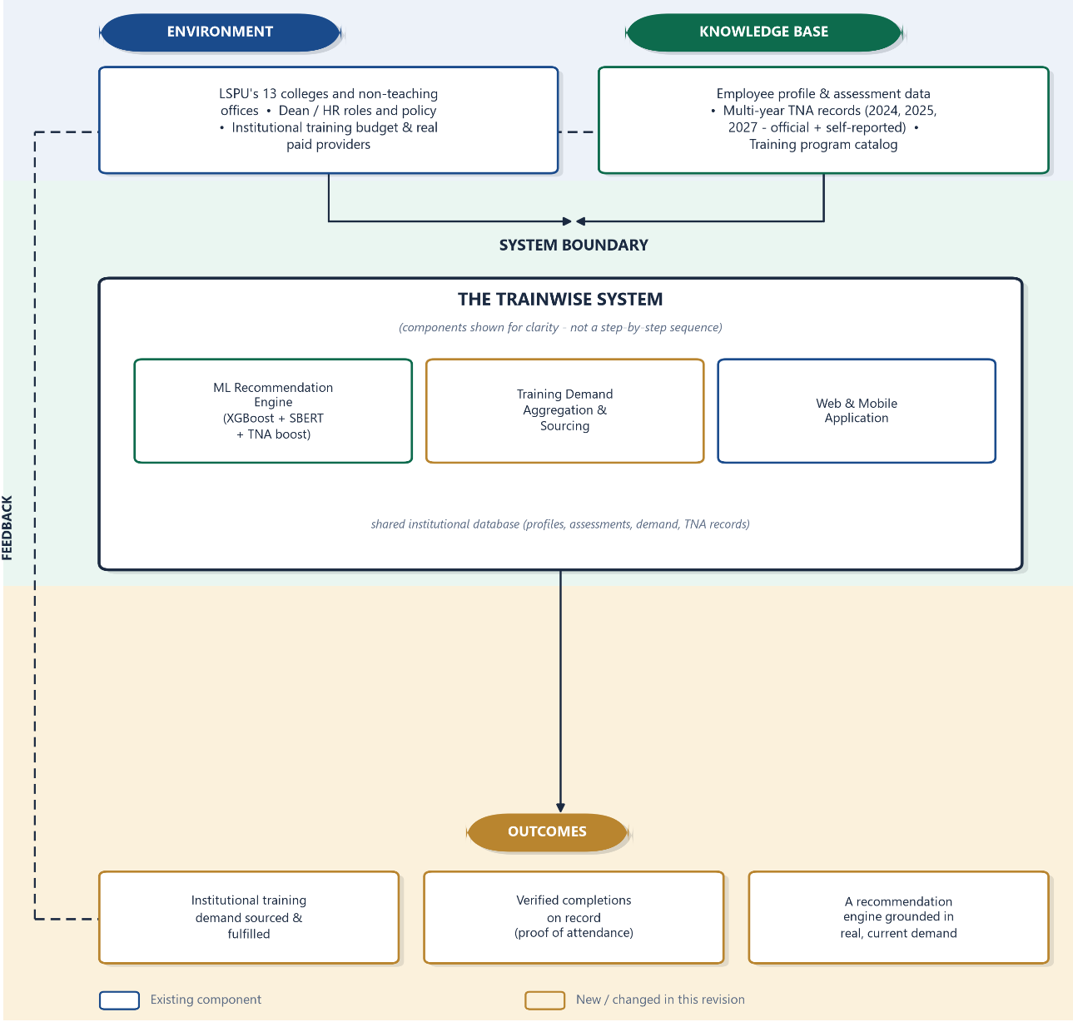

Figure 1. Conceptual Framework of the System
The framework is grounded in General Systems Theory, which views TrainWise not as a straight line from data to result, but as a living system that draws from its surroundings, works within a clear boundary, and continues to learn from what happens after a training is completed.
The system operates within a real institutional environment. This includes LSPU's colleges and non teaching offices, the roles and responsibilities of deans and the Human Resource office, and the institution's training budget and the real paid providers it can call on. This environment is what gives every recommendation and every sourced training its real world context.
Supporting the system is a knowledge base that it continually draws from. This includes employee profile and assessment information, the multi year Training Needs Assessment records covering 2024, 2025, and 2027, which combine official submissions from the colleges with what employees have shared on their own when no official record exists, and the catalog of available training programs. Together, these give the system a grounded and current picture of what LSPU's employees actually need.
Within the boundary of the system itself are three parts that work together rather than in a strict sequence. The recommendation engine combines an XGBoost model, which learns patterns from an employee's profile and role, with Sentence BERT, which reads and compares the meaning of what an employee has written about their training needs, and both are further guided by the Training Needs Assessment records so that a suggestion is not only personalized but also reflects real, current institutional demand. The training demand aggregation and sourcing component takes the requests that come out of this engine and pools them, so that the Human Resource office can see how many employees across the entire university are asking for the same kind of training, then route that request to the right college dean or source it directly. The web and mobile application is what employees, deans, and Human Resource staff actually use to submit assessments, view recommendations, review and act on pooled demand, and track a training from request to completion. All three parts read from and write to the same shared institutional database, which keeps their picture of the university consistent.
What comes out of the system are its outcomes. Institutional training demand gets sourced and fulfilled rather than sitting as an unread request. Completions are verified and kept on record through the proof employees submit, rather than being taken on trust. And the recommendation engine itself stays grounded in real, current demand instead of relying only on assumptions. These outcomes do not simply end the cycle. They feed back into the knowledge base, so that each completed training, each new assessment, and each year's Training Needs Assessment record becomes part of what the system draws on the next time it makes a recommendation.
Through this framework, TrainWise brings together the university's environment, its accumulated knowledge, and its working components into one continuously improving system, moving the training needs assessment process away from manual, opinion based methods and toward one that is automated, evidence driven, and able to grow more accurate the longer it is used.

CHAPTER III
METHODOLOGY

This chapter describes the techniques used to create and enhance TrainWise, a web and mobile solution that uses XGBoost and natural language processing to evaluate employee training needs and provide recommendations. The project design, system construction, architecture, database setup, testing procedures, and evaluation of the outcomes are all covered. To enable continuous planning, development, testing, and updates, the project employs the Web and Mobile Application Development track and the Agile Scrum methodology.
Project Design
The TrainWise project illustrates the connections between user requirements, system modules, database operations, and the recommendation engine using concepts from system design. The existing system is a responsive web platform for evaluating the training needs of employees. Users can create reports, manage development programs, assess employees, pool and source training demand, provide training materials, and maintain training records. A machine learning based recommendation engine is incorporated to offer tailored training recommendations grounded in the university's own real, current demand.
The TrainWise system architecture is displayed in Figure 2. The Users Layer, Frontend Layer, Backend Services Layer, Machine Learning Engine Layer, Database Layer, and Deployment Layer make up the six main layers of the architecture. The primary operations of the system, including the user interface, data processing, storage, demand pooling and sourcing, suggestion creation, and report generation, are supported by these layers working together. The final data and documents generated by the system, such as customized training recommendations, competency gap insights, assessment reports, Individual Development Plans, evaluation summaries, monitoring reports, confirmed training rosters, proof of completion records, and exported PDF documents, are represented by the System Outputs section of the architecture.
The various users of the system are displayed in the Users Layer. These users include the HR or system administrators, college deans or evaluators, faculty members or employees, and non teaching staff. The system is used by faculty and non teaching staff to complete their profiles, submit training needs forms, create their Individual Development Plans, accept a recommendation or express interest in a training their dean has posted, upload proof once a training is complete, and view their training outcomes. It is used by college deans or evaluators to monitor department submissions, evaluate employees, review training demand that HR has forwarded to their college, source a real training provider, and report back or post a training opportunity directly. User accounts, deadlines, assessment records and reports, the institution wide pool of training demand, and system administration are all handled by HR and system administrators. Each user can only see the features and data required for their function thanks to this configuration.
The portion of the system that users interact with via a web browser is known as the Frontend Layer. Because it was created using HTML, CSS, and JavaScript, it can be seen on desktop and mobile devices. Viewing dashboards, completing evaluation forms, checking profile pages, viewing results, reviewing and acting on pooled training demand, reading reports, and utilizing additional features are all possible with the frontend. TrainWise does not require a separate mobile app because it is responsive, meaning it functions well on many screen sizes.
The Backend Services Layer is the main processing component of TrainWise. Its PHP based application layer manages business logic, system workflows, database communication, report generation, and integration with the Python based recommendation engine. It encompasses the following modules:
Account Management Module. This module handles user registration, login authentication, account verification, and role based access control. It ensures that administrators, evaluators, faculty, and non teaching personnel can only access the features and data relevant to their designated role.
Profile Management Module. Users complete and update personal and professional information including department, designation, educational attainment, specialization, and years of service through this module. Profile data serves as one of the primary structured inputs used by the recommendation engine when generating training suggestions.
Assessment and Submission Module. This module collects both structured responses and free text inputs, such as desired training descriptions and comments, through the Training Needs Assessment form. All submitted data are stored in the database and made available for future processing by the recommendation engine.
Recommendation Module. This module displays the space where recommendation results appear. It is connected to the Python based machine learning engine, which delivers personalized training recommendations derived from the user's profile, their Training Needs Assessment submission, and their college's own institutional demand.
Training Demand Aggregation and Sourcing Module. Once an employee accepts a recommendation or expresses interest in a training a dean has posted, this module pools that request into the university's shared training demand rather than leaving it as one person's isolated suggestion. HR reviews this pooled demand, forwards each request to the relevant college dean or sources it directly when no dean applies, and the dean in turn sources a real, paid provider and reports back or posts a training opportunity of their own. Once a training is confirmed, this module also governs the proof of completion an employee must submit before it is recorded as finished, keeping a permanent, verified training history distinct from what an employee simply reports on their own.
Individual Development Plan (IDP) Module. Users create, edit, and submit development plans that outline their training objectives, target competencies, and planned activities. Administrators and evaluators may access these plans to monitor staff progress and guide training decisions.
Evaluation Module. Authorized evaluators, such as college deans, use this module to assess employee submissions at the department level, applying filters by department, status, and employee type to support organized performance review.
Reporting and Monitoring Module. Administrators access assessment submissions, IDP records, evaluation summaries, and pooled training demand through this module, with filtering and search functions that support efficient data retrieval and institutional monitoring. A separate audit log gives administrators a chronological record of key actions taken across the system, supporting accountability alongside monitoring.
Notification and Deadline Management Module. This module allows administrators to set Training Needs Assessment submission deadlines. Status updates and alerts, such as a newly forwarded training demand or a confirmed training, are delivered to users in app through the system's notification center rather than by email in the system's current version.
PDF Generation and Document Export Module. The system generates downloadable, printable documents including Training Needs Assessment reports, IDP forms, evaluation summaries, and institution wide training needs summaries, through this module, giving users and administrators formal copies of system generated records.
The Machine Learning Engine Layer is the intelligent enhancement layer of TrainWise. This layer is developed as a Python API that connects with the existing PHP based core system. The recommendation engine receives the assessment data and the desired training text from the backend services layer, along with the requester's college, and runs multiple processes to handle the data, including data preprocessing, structured data analysis, text embedding, semantic analysis, prediction based on XGBoost, similarity matching with Sentence BERT, and a check against the university's own multi year Training Needs Assessment records.
The XGBoost component analyzes structured data, including user profile information, department, role, and assessment responses, across fourteen categories of training need. Its objective is to recognize patterns in the data of the current system and suggest training programs that may be pertinent to the user. The SBERT component converts textual inputs into semantic representations and compares them with the descriptions of available training programs in order to process the user's desired training text, allowing the system to understand a request even when its wording does not match a program's title directly. A third component checks whether a request connects to what a college has officially requested in a Training Needs Assessment covering 2024, 2025, and 2027, or, where no official submission exists for that college, what colleagues in the same college have asked for on their own. Together these three signals let TrainWise generate a recommendation that is personalized to the individual, understands their request in their own words, and stays grounded in real, current institutional demand rather than any one of these alone.
MySQL is employed by the Database Layer to store and administer the system's data. It encompasses user profiles, assessment records, evaluation data, IDP records, notifications, deadlines, training program data, the pooled institutional training demand and its routing history, the multi year Training Needs Assessment records, the permanent log of completed trainings, and recommendation results. TrainWise's central storage is the database, which facilitates both the main system and the machine learning enhancement. It supplies the data required for the generation of documents, monitoring, demand sourcing, recommendation processing, and reporting.
The Deployment Layer describes the environment in which the system and its components operate. The PHP based web system is served through Apache via XAMPP, while the recommendation engine runs as its own Python service through Uvicorn, communicating with the core system over the local network whenever a recommendation is requested. Continuous monitoring is also offered to help with system maintenance, updates, and log checks. This layer ensures that both the core system and the machine learning service function properly.
TrainWise produces final results called System Outputs. These include training recommendations, insights into competency gaps, assessment reports, Individual Development Plans, evaluation summaries, administrative monitoring reports, confirmed training rosters with their proof of completion on file, and exported PDF documents. These outputs help users and administrators identify training needs, organize staff development plans, source and confirm real trainings, and make data driven training decisions.
In general, the TrainWise project design integrates the existing web based training requirements assessment system with an intelligent recommendation engine and an institution wide demand sourcing pipeline. The XGBoost, SBERT, and Training Needs Assessment components improve the system by generating more relevant, personalized, and demand grounded training recommendations, while the existing system provides the foundation for user administration, assessment collection, IDP creation, evaluation, demand pooling and sourcing, reporting, and documentation. TrainWise is transformed into a decision support tool for the assessment of training requirements and the development of employees as a result of this design, which elevates it beyond the realm of basic information management.

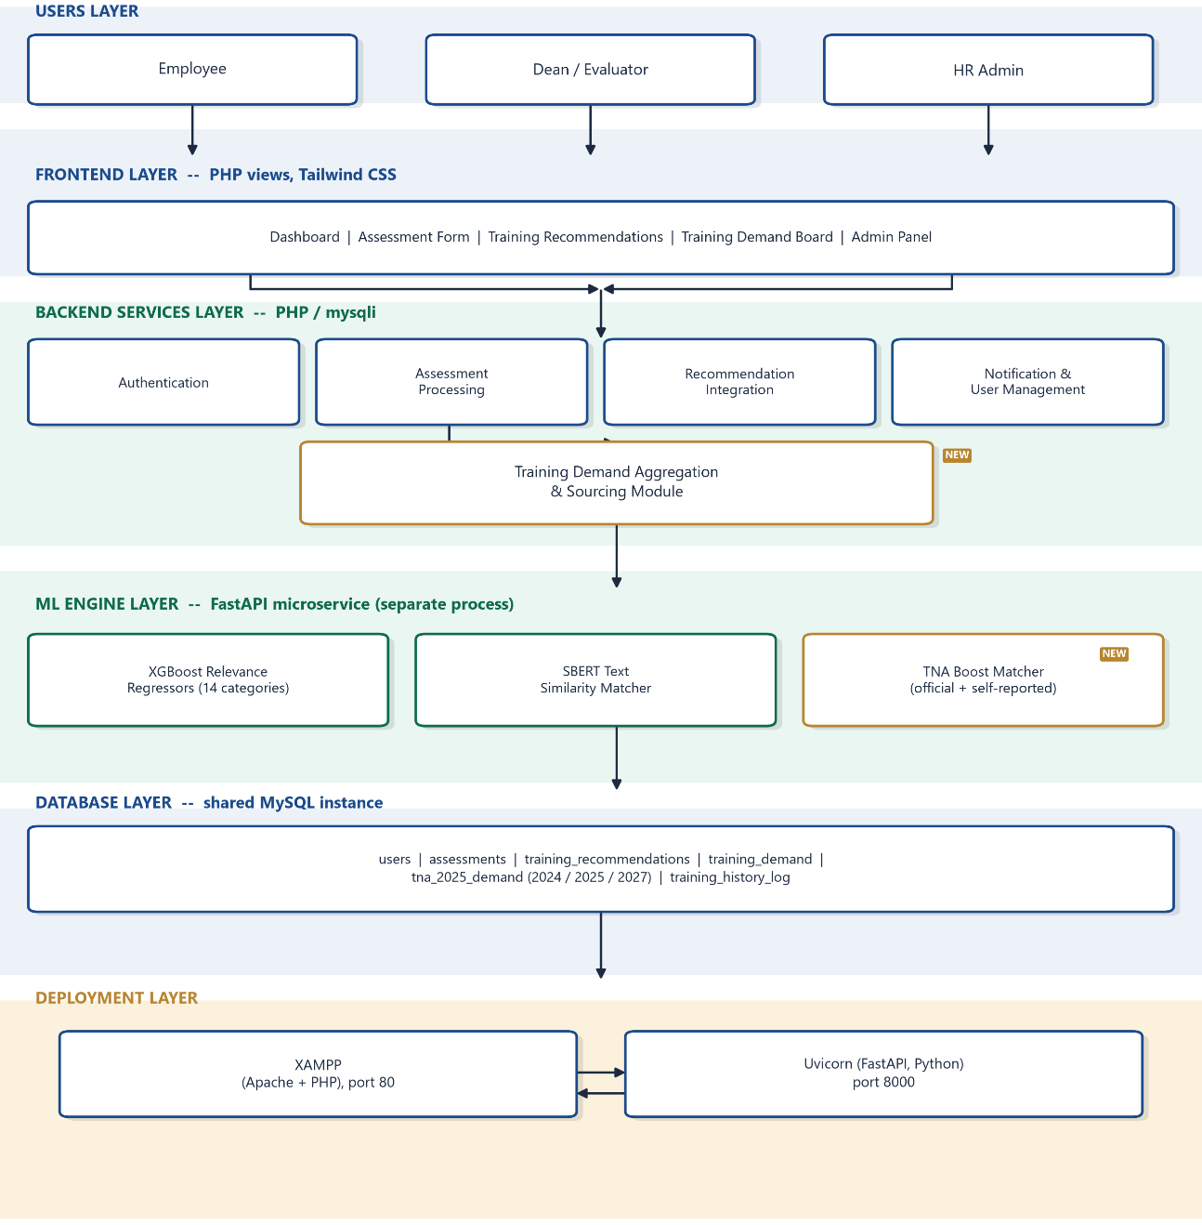

Figure 2. System Architecture

System Flowchart

This flowchart follows a training request from the moment an employee logs in to the moment it is confirmed complete, shown as three parallel paths for the employee, the college dean, and Human Resource, with arrows crossing between them at the points where one role hands work off to another.
The employee's path begins with logging in or registering, then completing their profile and assessment. Once that is submitted, they see their AI generated recommendations and can accept one or more, which pools their request into the university's shared training demand, they can also type the specific request that they want if the training recommendations from the machine learning is not the trainings that they want, also they cab express interest in a training a dean has posted directly. From there the employee waits to be notified that a training is available or confirmed, after which they upload their proof of completion, consisting of four required documents, before the system automatically mark it complete.
Once an employee accepts a recommendation, it reaches Human Resource, who reviews the university's pooled training demand and decides, for each request, whether a college dean can realistically source it. If a dean is available, the request is forwarded to that college. If not, for example when every requester belongs to a central administrative office with no dean of its own, Human Resource sources the training directly instead.
On the dean's path, a forwarded request is received and the dean works to source a real, paid training provider. Once a provider is found, the dean reports it back to Human Resource, or, if the dean already found a training on their own with no prior employee request behind it, posts it directly as an opportunity that their college's staff can see and join immediately.
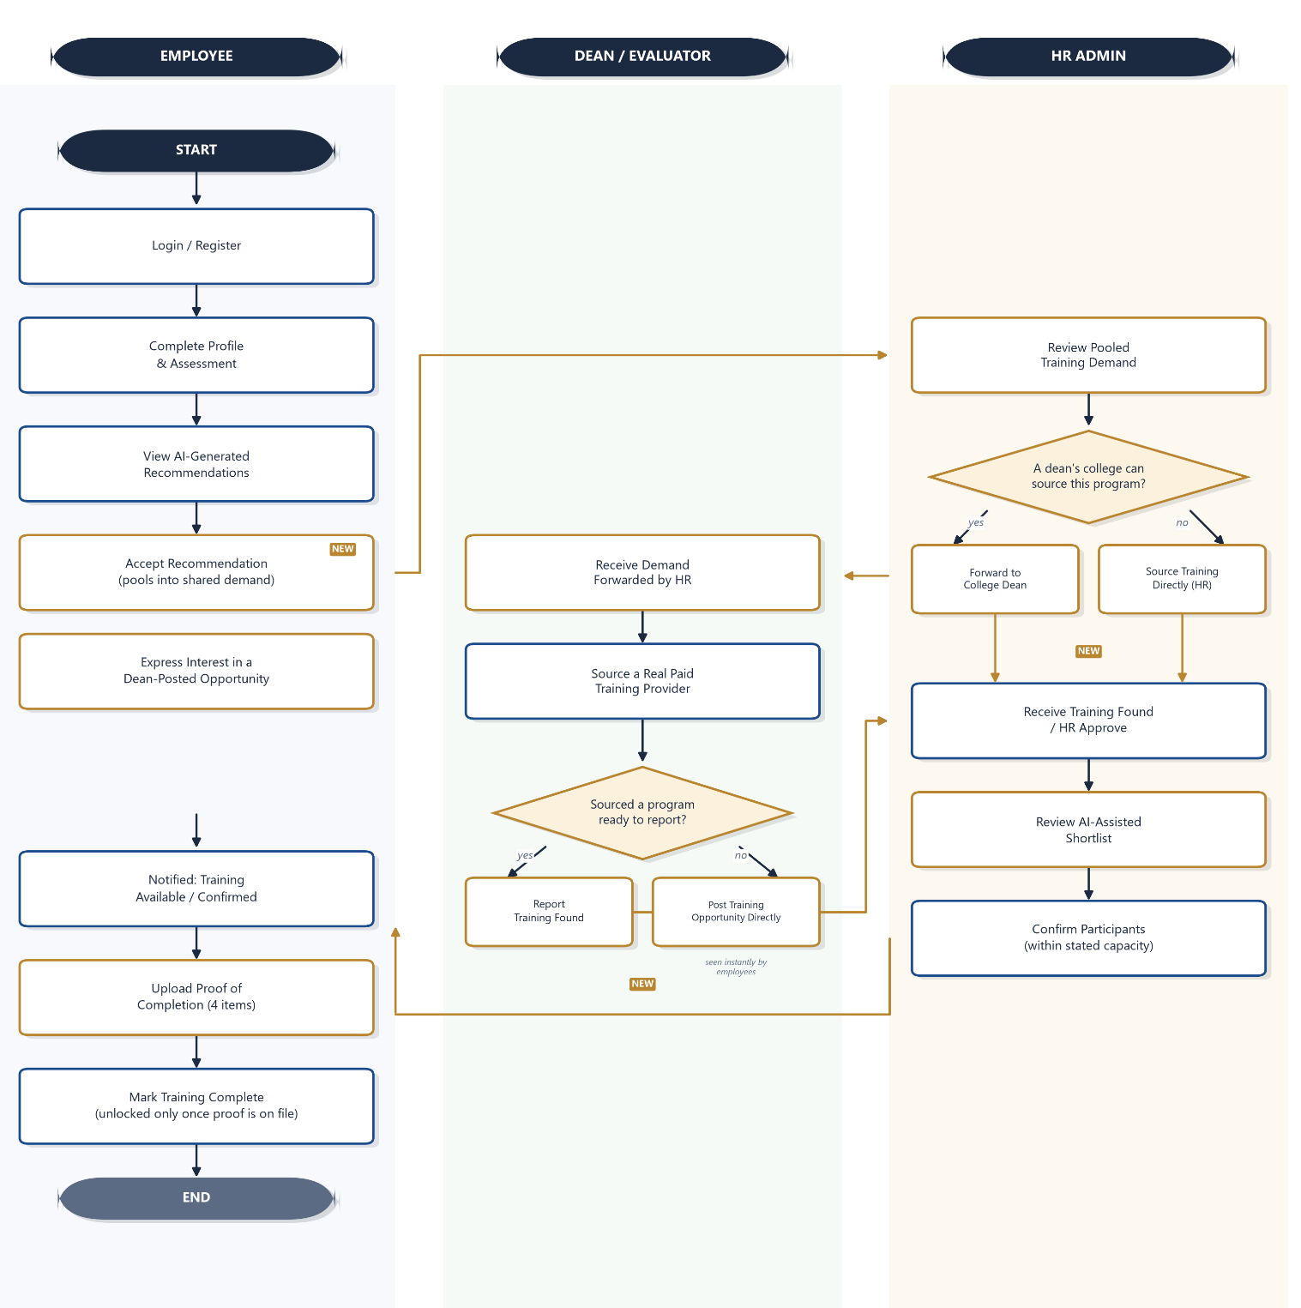
Back on Human Resource's path, once a training is reported as found, whether through a dean or sourced directly, Human Resource reviews it and approves it. This is where the AI assisted shortlist comes in, ranking the employees who requested that training so Human Resource can decide, with the system's support rather than its judgment overriding theirs, who to confirm within the training's actual capacity. Once participants are confirmed, they are notified on the employee side, completing the loop back to where the employee's own path picks up again.

Figure 3. System Flowchart of TrainWise

Use Case Diagram
Figure 4a and Figure 4b present the updated use case diagram of TrainWise, which illustrates the interaction between the system's actors and the actual functions of the web based employee training needs assessment and recommendation system. The diagram is split across two figures because the number of real functions each role has grown substantially since the system's demand sourcing pipeline was built, and fitting all of them into one diagram made the text too small to read on a printed page. Figure 4a covers the End User and the Recommendation Engine. Figure 4b places the College Dean or Evaluator and the HR Admin side by side, since their responsibilities in the demand pipeline are directly connected to one another. Both diagrams were designed to show the functional scope of the system in a readable, role based manner, focusing on the functions each actor directly triggers rather than the internal steps behind them.
The diagrams identify four main actors in total. The End User represents both Faculty Members or Employees and Non Teaching Personnel, since these users perform the same actions within the system regardless of their designation. The College Dean or Evaluator represents the authorized personnel responsible for reviewing submissions, evaluating employees, and sourcing trainings within their assigned college. The HR Admin represents the office responsible for system wide administration, deadlines, institution wide record review, and coordinating the training demand that comes in from every college. The Recommendation Engine represents the machine learning component, shown as its own actor because it is the system, not a person, that carries out the work behind an employee's recommendations.
For the End User, shown in Figure 4a, the system provides registering an account and logging in, managing the profile, taking the Training Needs Assessment, and creating and viewing the Individual Development Plan. From there, the employee views the recommendations generated for them and can either accept one, which pools their request into the university's shared training demand, or express interest in a training their dean has posted directly. Once Human Resource confirms them for a training, the employee uploads their proof of completion before the system allows them to mark it complete. Viewing notifications and logging out remain available throughout but are treated as ordinary account actions rather than separate use cases in the diagram. Alongside the employee, the Recommendation Engine is shown generating the ranked recommendations that make this whole path possible. This is a live, already integrated part of the system, combining an XGBoost model trained across fourteen categories of training need, a Sentence BERT model that reads the meaning of what an employee has written, and a check against the university's own multi year Training Needs Assessment records, not a feature planned for future integration.
For the College Dean or Evaluator and the HR Admin, shown together in Figure 4b, the diagram reflects two connected sets of responsibilities. The dean continues to review their college's assessment and Individual Development Plan submissions and evaluate faculty performance, the responsibilities the role already had, and now also receives training demand that HR has forwarded to their college, sources a real paid provider, and either reports it found or posts a training opportunity directly when they sourced one on their own initiative. The HR Admin carries the system's wider administrative load, approving or declining new registrations, managing user accounts, setting the assessment deadline each cycle, and reviewing assessment, IDP, and evaluation forms submitted across every college, in addition to viewing institution wide reports and the audit log. Alongside these existing duties, HR now also reviews the training demand pooled from every employee's accepted recommendation, decides whether to forward each request to a college dean or source it directly, and reviews the AI assisted shortlist that ranks requesters when it comes time to confirm who actually attends.
As in the earlier version of this diagram, the internal steps of the recommendation process, the XGBoost prediction and the SBERT similarity matching, are not shown as separate use cases. They remain folded into the single "Generate Ranked Recommendations" use case, with the underlying process explained in full in the system architecture and recommendation engine sections instead, so the diagram stays readable rather than overcrowded.
Overall, the two diagrams show how TrainWise now functions as more than a submission and evaluation platform. An employee's accepted recommendation does not end at their own screen. It becomes part of a real, tracked pipeline that a dean sources and HR confirms, closing the loop between what an employee needs and what the institution actually delivers.
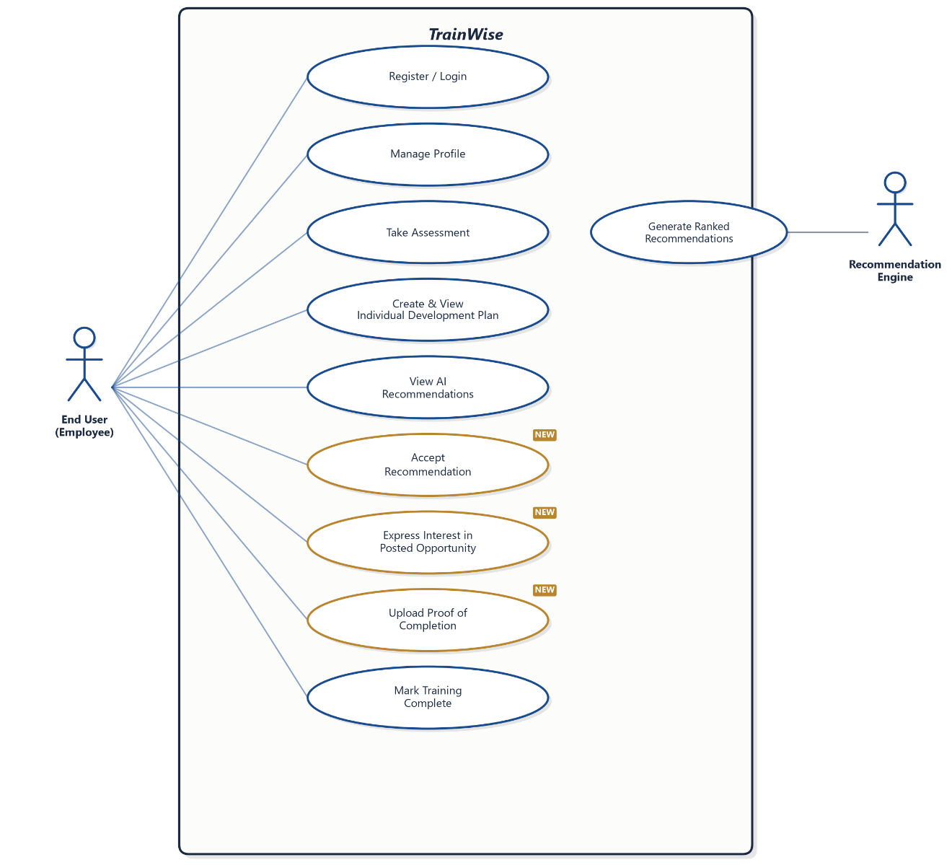

Figure 4a. Use Case Diagram – Employee

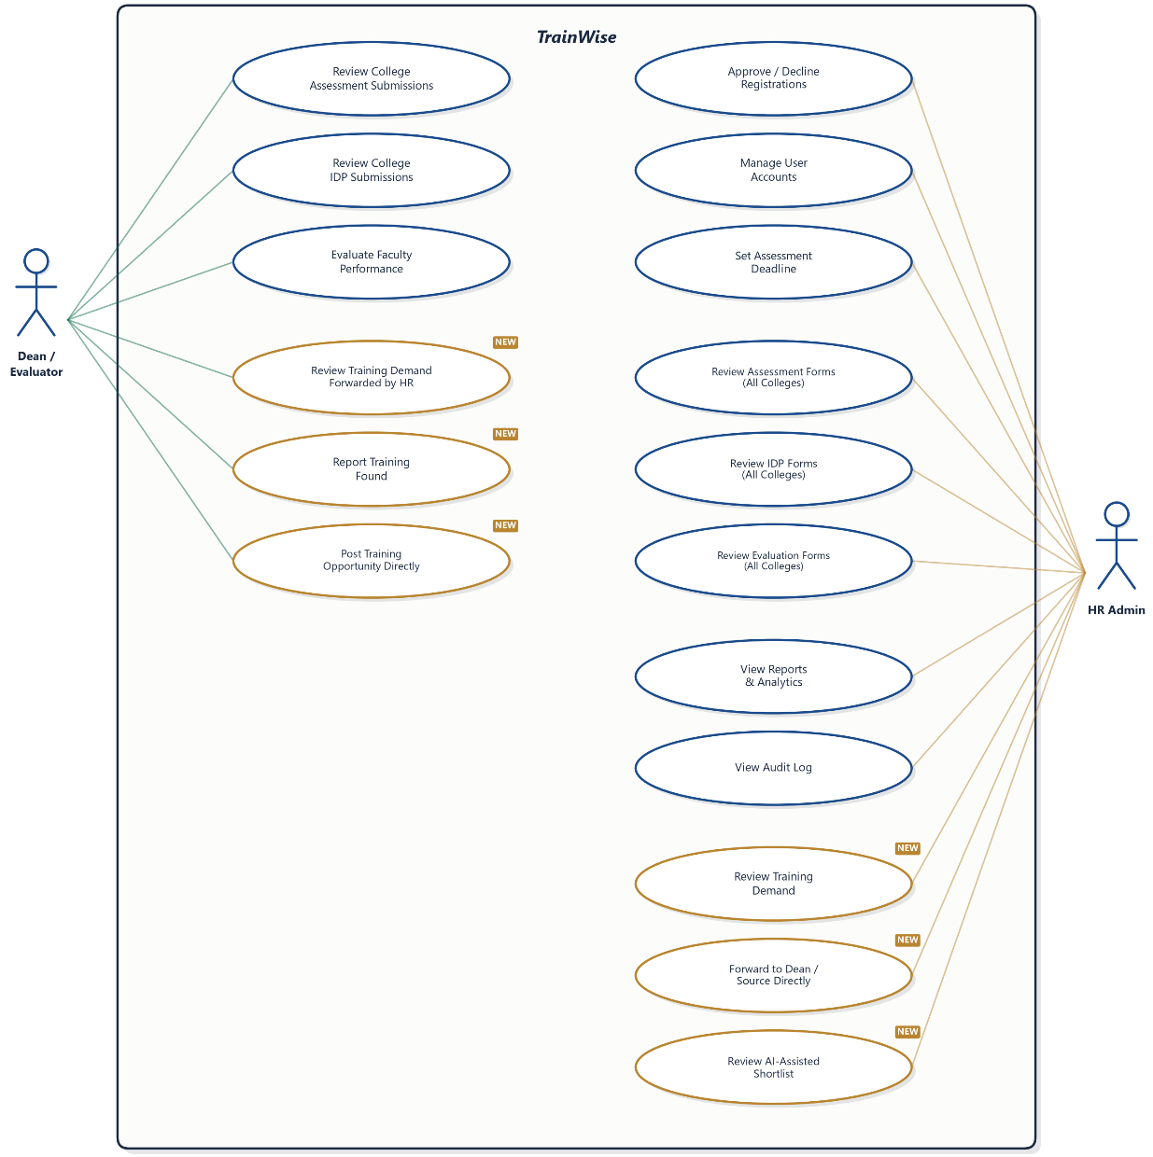

Figure 4b. Use Case Diagram – Dean and Human Resource Administrator

Recommendation Engine and Machine Learning Process
The Recommendation Engine is the intelligent component of TrainWise, integrated into the existing web-based employee training needs assessment system. TrainWise functions as a training needs assessment and management platform where users can register, log in, complete their profiles, submit Training Needs Assessment (TNA) forms, create or update Individual Development Plans (IDPs), receive notifications, and allow authorized personnel to monitor submissions, evaluations, and reports. The machine learning-based recommendation feature described in this section has been developed and integrated into the current version of the system.
This section presents the machine learning process that serves as the basis for the TrainWise Recommendation Engine. The recommendation engine analyzes submitted employee data and training-related inputs to generate personalized, data-driven training recommendations. The engine uses XGBoost for structured data analysis and Natural Language Processing, specifically Sentence-BERT (SBERT), for analyzing textual inputs such as desired training, comments, and training history.
The inclusion of this component addresses the fact that the system already collects extensive training needs assessment data that can be used for intelligent analysis, including user profile information, department, role, employee type, training history, assessment responses, IDP records, and evaluation results. Rather than limiting the system to manual review and administrative monitoring, the recommendation engine supports decision-making by transforming collected profile and assessment data into meaningful training suggestions.
Current System Status
TrainWise is now running as a web-based system for training needs assessment. It lets users register accounts, manage profiles, submit TNA forms, create IDPs, and handle evaluations, reports, notifications, and document exports. These features set the stage for adding recommendations in the future, since they help the system gather and store the data needed for machine learning.
TrainWise now performs automated machine learning inference for its training recommendation feature. The Recommendation Engine, implemented as a separate Python based service built with FastAPI, communicates with the main TrainWise web application and its MySQL database over HTTP. When a user completes their profile or submits a Training Needs Assessment, the web application calls this service, which analyzes the employee's structured profile data using a trained XGBoost model and free text input, such as desired training, comments, and training history, using a Sentence BERT semantic similarity model. The service then returns a ranked list of relevant training programs, displayed on the Training Recommendations page and the user dashboard.
Machine Learning Component
The machine learning component processes structured profile data and free text assessment input submitted through the user's profile and the TNA form. It was developed as a separate Python based Recommendation API, built with FastAPI, that communicates with the existing TrainWise web application and MySQL database over HTTP.
The process begins when an end user completes their profile or submits a Training Needs Assessment form. The relevant data is stored in the MySQL database and requested by the web application from the Recommendation API for processing. The API cleans and prepares the data, analyzes structured employee information (department, designation, position, employment or teaching status, years of service, and educational attainment) using XGBoost, processes free text input using SBERT, combines the two resulting scores, and returns a ranked list of recommended training programs to the main system. Individual Development Plan submissions and evaluation results were considered as potential inputs during planning, but were not included in the implemented feature set. This is noted here as a direction for future enhancement rather than a limitation of the present design, since profile and assessment data already supply both the structured and unstructured signal types the model needs.
This implementation follows the planned modular design. The main TrainWise web system continues to handle user interaction, form submission, dashboard access, reporting, and database transactions, while the Python Recommendation API handles the machine learning and Natural Language Processing tasks. This separation made the recommendation engine straightforward to retrain, evaluate, and improve independently of the main web application, as shown in the model evaluation and tuning work described later in this chapter.

XGBoost Component for Structured Data
XGBoost is used to analyze the structured employee data collected by TrainWise: department, designation, employment or teaching status, years of service, and educational attainment. This data is engineered into a small set of categorical and boolean features before being passed to the model, including a canonicalized department code, whether the department is technology adjacent, a seniority bucket derived from years of service, an educational attainment bucket, and whether the employee holds a leadership type designation.
Rather than a single multi class classifier, the implementation trains one XGBoost regressor for each training category, each predicting a continuous relevance score between 0 and 1 for that category given an employee's features. The set of categories began with eight (Pedagogy, Research, Technology, Assessment, Leadership, Administration, Communication, and Student Affairs) and was later expanded to fourteen as genuine gaps in subject coverage were identified during testing: Records Management, Finance and Compliance, Public Service, Health and Nutrition, Criminal Justice, and Gender and Development were added so that colleges whose day-to-day work did not fit cleanly into the original eight categories, such as the College of Criminal Justice Education or the university's non-teaching offices, would still receive recommendations grounded in their actual field.
This regression based design was chosen because the recommendation task is fundamentally a ranking problem: the system needs a continuous relevance score to order multiple training programs against each other, not a single predicted label, and a regressor produces exactly that. The model is accordingly evaluated using Mean Absolute Error, Root Mean Squared Error, and the coefficient of determination (R²), the standard metrics for a regression task, rather than Accuracy, Precision, Recall, and F1 Score, which apply to classification. This same substitution is reflected in the updated Table 11 later in this chapter.
As with the original design intent, the purpose of using XGBoost is not to replace the judgment of HR administrators or evaluators, but to serve as a decision support tool that identifies possible training needs faster and more consistently. Generated recommendations remain visible to, and can be reviewed by, authorized personnel before being treated as final.
Natural Language Processing Component Using SBERT
In addition to structured data, TrainWise also collects textual inputs from users, especially through desired training fields, comments, suggestions, and open-ended assessment responses. These text-based inputs are important because users may describe their training needs in their own words. However, manual interpretation of these responses can be time-consuming, especially when many employees submit assessment forms.
TrainWise uses Sentence BERT for this Natural Language Processing task, specifically the pretrained multi-qa-MiniLM-L6-cos-v1 model. This variant was selected because it is purpose built for matching short queries against longer descriptive passages, which is precisely the structure of matching a brief training request against a multi sentence training program description, rather than comparing two similarly sized texts. Both the user's free text input (desired training, comments, and training history) and each training program's description are converted into sentence embeddings, and training programs are ranked by cosine similarity between the two.
This allows TrainWise to recommend training programs based on semantic similarity instead of exact keyword matching. For example, a query about "data protection and online security" can still match a program titled "Cybersecurity Awareness," even though the two share no exact keywords.
Recommendation Generation Process
The recommendation generation process begins when the user completes their profile or submits the Training Needs Assessment form. The submitted data is stored in the MySQL database, and the relevant profile and assessment fields are sent to the Python Recommendation API.
The XGBoost component analyzes the structured employee data to produce a relevance score for each training category. At the same time, the SBERT component compares the user's desired training text against the available training program descriptions. The system combines the two scores to rank the most relevant training programs.
After ranking, the recommendation engine returns the ranked training programs to the TrainWise web application. These recommendations are displayed on the user dashboard and the standalone Training Recommendations page, and stored in the database for future reference. The user may use the recommendations as a basis for creating or updating their Individual Development Plan.
How the Final Recommendation Score Is Computed
Once the structured score from XGBoost and the text-similarity score from SBERT are produced for a given employee and training program, they are not simply averaged. They are combined using the formula:
$$Combined Score= \left(Structured Weight × Structured Score\right)+$$
$$(Text Weight × Text Score) + (TNA Weight × TNA Boost)$$

The two weights are not fixed; they shift depending on how specific and clear the employee's own written request was. If the employee's request is a strong, specific match to at least one program in the catalog, the system leans heavily on that specific match: the text weight rises to 0.92 and the structured weight falls to 0.08. If the employee's request is vague or does not closely match anything specific, the system instead falls back on what is generally true for someone in that role and department: the structured weight rises to 0.4 and the text weight is 0.6. This reflects the same reasoning a human training coordinator would use: when someone clearly states what they want, take their word for it; when they do not give much to go on, fall back on what is typical for their position. The Training Needs Assessment weight is added on top in either case, at 0.2 when the employee's college has an official record on file, or 0.12 when it is instead based on what colleagues in the same college have said in their own individual assessments, and is scaled down proportionally in the specific-request case so it does not override a clear personal request.
Training Demand Aggregation and Institutional Sourcing
Because the recommendation engine identifies relevant topics rather than specific bookable sessions, TrainWise pools individual acceptances of the same topic, whether suggested by the system or typed freely by the employee, into a single record representing shared interest across the institution. Free-text requests that do not match an existing catalog title are grouped using the same sentence-embedding technique described earlier: requests are first separated by the requesting employee's college, since a training request from one college is, in practice, never the same underlying need as a similarly worded request from an unrelated college, and only requests within the same college are then compared and grouped together when they are similar enough in meaning.
Each pooled request moves through a defined sequence: it is first reviewed by Human Resource personnel, then forwarded to the relevant college dean to locate a provider, or, for a request made up entirely of employees from an office with no dean, handled directly by Human Resource personnel instead. Once a dean or Human Resource personnel reports back with a specific provider, cost, schedule, venue, and format, that information is recorded and the training type, whether a workshop, seminar, webinar, or conference, is captured for the first time at this point, since neither the system nor Human Resource personnel can know in advance what form a session that has not yet been located will take. A college dean may also post a training opportunity directly, without waiting for any prior employee request, which employees in that college may then independently express interest in.
Assistive Ranking for Final Selection
Once a training has been located and approved, and the number of interested employees may exceed the available slots, TrainWise computes a ranked list of interested employees to support, not replace, the final decision made by Human Resource personnel. Each employee's position in this ranking is computed as their years of service, minus three times the number of trainings they have already been confirmed for or completed, plus a bonus of five points if their college officially identified a similar need in a prior Training Needs Assessment, or three points if no official record exists for their college but colleagues in the same college have expressed a similar need in their own individual assessments. They are combined using the formula:
$$Score = (Years of Service × 1.0) - (Prior Trainings Completed × 3.0) + TNA Bonus$$
where the TNA Bonus is a flat five points if the employee's college officially requested a similar training in a prior Training Needs Assessment, three points if no official record exists but colleagues in the same college have expressed the same need in their own assessments, or zero if neither applies.
An employee who has already completed a training that closely resembles the one being filled is removed from consideration entirely rather than simply ranked lower, while an employee who has completed something loosely related is kept in consideration but flagged for Human Resource personnel's awareness. Human Resource personnel are shown the complete ranking, including anyone removed from consideration and the specific reason why, and make the final decision on who is confirmed.

System Integration
The Recommendation Engine is integrated into TrainWise through a Python based API. The existing TrainWise web application continues to handle the user interface, role based access, form submission, report generation, and database management, while the Python API handles the machine learning and NLP related processes.
The PHP based web application sends the necessary assessment and profile data to the Python API over HTTP. The API processes the data using the XGBoost and SBERT components described above, generates the recommendation output, and sends the result back to the main system. The recommendation results are then stored in the MySQL database and displayed to the user.
This design keeps the two systems loosely coupled, allowing the recommendation engine to be retrained, evaluated, and improved independently of the main web application.
Algorithm Analysis
This section presents the algorithm analysis of TrainWise's intelligent recommendation engine. It covers the model evaluation approach used for both components, and the Data Model Generation process, which outlines the step by step procedure that was followed to build, train, test, and validate the XGBoost and Sentence BERT (SBERT) components of the system.
Model Evaluation
NLP Evaluation Metrics
The performance of the recommendation component is evaluated using metrics appropriate to each component's task. Because the XGBoost component is implemented as a regressor, predicting a continuous 0 to 1 relevance score per training category rather than a classifier, its performance is evaluated using Mean Absolute Error, Root Mean Squared Error, and the coefficient of determination (R²), instead of Accuracy, Precision, Recall, and F1 Score, which apply to classification tasks.
Mean Absolute Error (MAE) measures the average magnitude of the difference between the predicted relevance score and the target score, without considering direction; a lower MAE indicates predictions that are, on average, closer to the target.
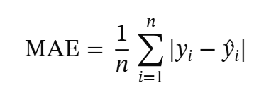
The formula to calculate the mean absolute error is:

Root Mean Squared Error (RMSE) similarly measures prediction error, but squares each difference before averaging, which penalizes larger errors more heavily than MAE does.
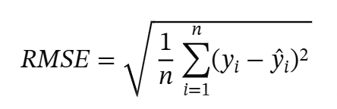
The formula to calculate the root mean squared error is:

The coefficient of determination (R²) measures the proportion of variance in the target scores that the model's predictions explain, relative to simply predicting the average target value every time; an R² closer to 1.0 indicates the model explains most of the variance in relevance scores.
The formula to calculate R-squared is:
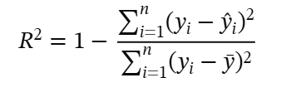

Cosine Similarity evaluates the semantic closeness between the employee's desired training text and available training program descriptions. A value closer to 1.0 indicates a stronger match and is the primary evaluation metric for the SBERT component.

The formula to calculate the cosine similarity is:

For the XGBoost component, the MAE, RMSE, and R² metrics defined above were applied to the held-out 20 percent test split, with results reported in the Model Testing section of this chapter. Expert validation, in which HR administrators, college deans, or authorized evaluators assess whether recommended training programs align with an employee's profile and development needs, was considered as a complementary evaluation approach and remains a recommended next step.
Data Model Generation
The Data Model Generation outlines the step by step process that was followed to build the recommendation model of TrainWise.
Model Selection
The recommendation engine uses a hybrid approach combining XGBoost for structured data analysis and Sentence BERT for Natural Language Processing. XGBoost was selected because it efficiently handles structured tabular data such as employee department, designation, employment status, and years of service stored in the TrainWise MySQL database. SBERT was selected because it generates sentence embeddings that capture semantic meaning, enabling the system to match employee submitted desired training text with training program descriptions even when exact keywords do not match.
Data Collection and Preparation
Structured data comes from the users table: department, designation, employment or teaching status, years in LSPU, and educational attainment. Two additional fields, specialization and training history, are combined with the free text assessment fields (desired skills and comments) and processed through the SBERT text similarity component, rather than encoded as XGBoost categorical features. Specialization in particular is free form text, made up of specific field or subject names rather than a small fixed set of categories, which makes it better suited to semantic text matching than categorical encoding. As of this writing, the reference catalog contains 54 programs across 20 descriptive categories. Coverage of this catalog was verified directly against real employee submissions and against three years of the university's official Training Needs Assessment records (2024, 2025, and 2027, the only years for which official records could be obtained), and expanded whenever a real submitted need had no genuine match among the existing programs. The catalog is deliberately limited to group-oriented training formats, workshops, seminars, webinars, and conferences, since a self-paced course does not require the coordination that the pooling and sourcing process described above is meant to provide; an employee may pursue such a course independently. Before model training, the completeness and accuracy of these database records must be verified to ensure reliable output002E
Data Annotation
Because the live assessments table does not yet contain a sufficient volume of complete, non placeholder responses to serve as a labeled training set, a synthetic bootstrap dataset was constructed instead of waiting for organic data to accumulate. This is a documented and commonly used strategy for cold start recommender systems, where no historical interaction or preference data yet exists for the item space being recommended. A set of explicit, hand authored domain rules was encoded, mapping combinations of employee attributes to a base relevance score for each of the eight training categories. These rules generate 3,600 labeled training examples, covering all 720 possible combinations of the encoded attributes with five samples each and added Gaussian noise, that XGBoost is trained against. This bootstrap approach is treated as a starting point and not a permanent label source; it confirms that the modeling pipeline correctly learns whatever relationship exists between employee attributes and category relevance, but it does not by itself confirm that the encoded rules reflect real LSPU staff training needs.
Obtaining real, individually labeled training-request data directly from Human Resource records was considered as an alternative to the synthetic approach above, but was not pursued for reasons rooted in data privacy rather than availability. While Human Resource personnel were able to provide consolidated, college-level summaries of officially requested training topics for three academic years (2024, 2025, and 2027), releasing records that identify which specific employee requested which specific training would require a separate process involving additional consideration and permission, since an individual employee may not be aware that a record naming them would be shared for research purposes. Consistent with the ethical standards described later in this chapter, this study did not pursue that request. The consolidated summaries that were made available are instead used as a secondary, institution-level reference that the recommendation engine checks against, described further in the Data Collection and Preparation section. Two additional years were not obtainable through the same office: the 2026 assessment was conducted independently by a different LSPU campus (Santa Cruz) using a different collection method, and records prior to 2023 predate the current Human Resource officer's tenure; in both cases, the researchers chose not to pursue records that the office responsible for providing them had not itself prepared or had authority over.
Data Preprocessing
For structured data processed by XGBoost, preprocessing includes handling missing values, canonicalizing free text department values into a fixed set of department codes, necessary because the live department column contains many spelling and formatting variants of the same college name, and bucketing fields such as years of service and educational attainment into a small number of categories. For text data processed by SBERT, no manual lowercasing or stop word removal pipeline was required. SBERT's pretrained tokenizer is designed to operate directly on natural, unprocessed text, unlike the older bag of words methods that classical NLP pipelines were built around.
Data Splitting
The synthetic labeled dataset of 3,600 examples was divided into 80 percent for training and 20 percent for testing, per category, using a fixed random seed for reproducibility. This split follows standard machine learning practice and ensures that the model is evaluated on data it has not previously seen.

Model Experimentation
Model experimentation was conducted through a three fold cross validated grid search on the training split, evaluating 27 combinations of XGBoost hyperparameters per category: number of estimators (100, 200, or 300), maximum tree depth (3, 4, or 5), and learning rate (0.03, 0.05, or 0.1). The configuration with the lowest mean absolute error across folds was selected for each category. Across all eight categories, the best performing configuration was consistently a shallower, slower learning tree (100 estimators, maximum depth 3, learning rate 0.05) than the initial default configuration. For SBERT, the multi-qa-MiniLM-L6-cos-v1 model variant was selected for its suitability to short query versus longer passage matching.

Model Testing
Testing was conducted on the reserved 20 percent test split, which the grid search never saw. Because the XGBoost component is implemented as a regressor rather than a classifier, model quality was evaluated using Mean Absolute Error, Root Mean Squared Error, and R² rather than Accuracy, Precision, Recall, and F1 score. Across the eight training categories, the model achieved an average MAE of 0.041, an average RMSE of 0.051, and an average R² of 0.92, with individual category R² ranging from 0.80 for Technology to 0.98 for Pedagogy, indicating the model reliably learned the relationship between employee attributes and category relevance encoded in the training data.
The SBERT component was evaluated separately using a hand curated set of eighteen query and program pairs, one paraphrased and realistic training request per catalog program, deliberately worded to avoid reusing the target program's own title or key terms so that a correct match demonstrates genuine semantic understanding rather than keyword overlap. The model ranked the expected program first for 89 percent of queries (16 of 18) and within the top three results for 100 percent of queries, with a Mean Reciprocal Rank of 0.944.
The combined Recommendation API's response time was also benchmarked. Across twenty sequential requests, the mean response time was 0.14 seconds, with a maximum of 0.27 seconds. Under ten simultaneous concurrent requests, the mean response time was 0.92 seconds, with a maximum of 1.23 seconds, both well within the five second target.

Model Development
The Python-based Recommendation API, built with FastAPI, serves as the bridge between the existing TrainWise PHP web application and the machine learning components. The trained XGBoost models, one regressor per training category, are saved as a serialized model file. The SBERT model generates and caches embeddings for all training program descriptions stored in the database when the service starts. When a user completes their profile or submits a TNA form, the web application calls the API, which encodes the structured profile fields for XGBoost, computes SBERT cosine similarity scores for the free text input, combines the two resulting scores, ranks the training programs, and returns the top recommendations to the TrainWise web application for display on the dashboard and storage in the database.

Development Status and Limitation
At the current stage, the Recommendation Engine is a functioning intelligent feature of TrainWise. The existing system supports the collection and management of training needs assessment data, and this data now feeds an implemented machine learning-based recommendation pipeline using XGBoost and SBERT, described in the preceding sections.
The existing system provides the operational foundation for training needs assessment, while the recommendation engine serves as an enhancement built on that foundation, improving the accuracy and personalization of training recommendations.
The recommendation engine remains limited by the quality and quantity of data available in the system. Incomplete user profiles, unclear desired training inputs, a limited training program catalog, and the current reliance on a synthetic bootstrap dataset for XGBoost, discussed in the Data Annotation section, may affect model performance. The system also does not include real-time model retraining or integration with external training platforms within its current scope; both remain directions for future enhancement.
Overall, the Recommendation Engine strengthens TrainWise by adding intelligent analysis to the existing training needs assessment process. XGBoost analyzes structured employee data, while SBERT interprets textual training needs. This hybrid approach allows the system to provide more relevant, personalized, and data-driven training recommendations, while still allowing HR administrators and evaluators to review and validate the results before they are treated as final.
Materials for Software Development
This section presents the software and hardware materials used in the development and deployment of TrainWise: A Web and Mobile-Based Employee Training Needs Assessment and Recommendation System using XGBoost and Natural Language Processing. The materials were selected based on their relevance to the existing system modules, database operations, administrative processes, user interaction, document generation, and the integration of the machine learning-based recommendation engine.
The TrainWise platform is built as a PHP and MySQL-based web application, with the intelligent recommendation engine implemented as a separate Python-based service. The materials are accordingly grouped into two categories: the first covers the tools used for the existing TrainWise web application, and the second covers the tools used for the Python-based recommendation engine.

Software. This section presents the software tools used in developing the existing TrainWise system and the software tools used for the machine learning enhancement, along with their specific roles in the development process.
Visual Studio Code serves as the primary source code editor for TrainWise, providing a unified environment for editing PHP, HTML, CSS, JavaScript, and SQL files across all system modules. It is also used for writing and maintaining the Python-based Recommendation API.
HTML defines the structure of every TrainWise web page, organizing the forms, tables, navigation menus, and dashboard layouts that users interact with. All role-specific pages — including the TNA submission form, IDP form, evaluation forms, and administrative monitoring pages — are built on HTML and rendered consistently across desktop and mobile browsers.
CSS and Tailwind CSS control the visual appearance and responsive layout of the TrainWise interface. Tailwind CSS provides utility-based design classes applied directly to interface components, ensuring consistent styling and adaptability across screen sizes without requiring a separate mobile application.
JavaScript handles client-side interactivity in TrainWise, including form validation, modal windows, dynamic content display, and real-time interface updates. It validates required fields before TNA and IDP submissions, reducing input errors and improving usability for all user roles.
PHP serves as the server-side scripting language of the existing TrainWise system, managing all major backend operations including user authentication, session handling, role-based access, form processing, database communication, and report generation.
MySQL / MariaDB is the database management system of TrainWise, storing all user accounts, profile records, TNA submissions, IDP data, evaluation results, deadlines, notifications, and training program data. The database has been expanded with additional tables for recommendation outputs, including the training program catalog and stored recommendation results.
Following an internal review of the system against the security characteristic of the ISO/IEC 25010 model, several improvements were made prior to user testing: database and email credentials were moved out of the application's source code into a separate, access-restricted configuration file; session cookies were configured to resist common cross-site attacks; and role-based access checks were reviewed and corrected across all thirteen college-level administrative pages to ensure that a college dean cannot view another college's assessment records.

XAMPP and phpMyAdmin provide the local development and testing environment for the PHP and MySQL components of the system. phpMyAdmin serves as the graphical interface for managing database tables, records, and contents throughout development.
FPDF and jsPDF support the PDF document generation features of TrainWise, producing downloadable TNA reports, IDP documents, evaluation summaries, and other printable records required by users and administrators.
PHPMailer enables the automated email notification features of the system, sending registration updates, deadline alerts, and system reminders to users, evaluators, and administrators.
Web Browser (Google Chrome or Microsoft Edge) is the access point for all TrainWise users, since the platform is fully browser-based and requires no installation. The system is designed to function consistently across updated browsers on any internet-connected device.
Web Hosting Environment. The existing TrainWise system is deployed on a PHP- and MySQL-compatible hosting environment (InfinityFree) that supports file deployment, database connections, user sessions, and web-based access for LSPU Los Baños Campus users. The recommendation engine runs locally as a separate Python service during development; a separate Python-compatible hosting service remains a planned requirement for production deployment of its API.

Software for the Recommendation Engine

Python
Python is proposed as the main programming language for developing the intelligent recommendation engine. It is suitable for machine learning and Natural Language Processing because it supports libraries for data processing, model development, text analysis, and API deployment. In the proposed TrainWise enhancement, Python is intended to process structured data such as department, role, employee type, specialization, designation, years of service, training history, and assessment records, and unstructured data such as desired training inputs, comments, suggestions, and training program descriptions, for the generation of recommendation outputs.

FastAPI
FastAPI is used as the framework for creating the Python-based Recommendation API. The API serves as the bridge between the existing PHP-based TrainWise system and the machine learning component, allowing the PHP system to send selected user and assessment data to the machine learning service and receive recommended training programs in return. FastAPI supports RESTful API development, structured request handling, automatic documentation, and efficient data request processing. In this architecture, the TrainWise PHP system continues to handle the main web application, while FastAPI handles the recommendation process as a separate, independently testable service.

XGBoost
XGBoost is used as the machine learning algorithm for analyzing structured employee and assessment data. It identifies patterns from categorical and numerical data related to employee training needs, using input features such as department, employment or teaching status, years of service, and educational attainment. In the TrainWise recommendation engine, XGBoost supports prediction and ranking of training category relevance based on available structured data. XGBoost has been trained on a synthetic bootstrap dataset (see Data Annotation, Chapter 3) and evaluated on a held-out test split, achieving an average R² of 0.8685 across the fourteen training categories, detailed further in this chapter.

Sentence-BERT / SBERT
Sentence-BERT, or SBERT, is used as the Natural Language Processing model for analyzing textual training needs and training program descriptions. Unlike basic keyword matching, SBERT generates sentence embeddings that capture semantic meaning, enabling the system to compare the meaning of an employee's desired training input with the descriptions of available training programs even when exact keywords do not match. In the TrainWise recommendation engine, SBERT processes text fields such as desired skills, comments, and training history to generate more meaningful and context-aware recommendations.

Pandas, NumPy, and scikit-learn
Pandas, NumPy, and scikit-learn are the Python libraries used for data preparation, preprocessing, and model evaluation. Pandas is used to organize and clean tabular data from the TrainWise database. NumPy supports numerical operations, particularly when working with vectors and arrays. scikit-learn handles feature encoding, dataset splitting, and evaluation metrics. These libraries support the preparation of user profile data, assessment records, and training program data before processing by XGBoost or SBERT, and are used to evaluate recommendation quality: scikit-learn's regression metrics (MAE, RMSE, R²) for the XGBoost component, and cosine similarity for the SBERT component.
Python API Hosting
A separate Python-compatible hosting environment is proposed for the future deployment of the Recommendation API. Since the existing TrainWise system runs on a PHP and MySQL-based environment, the machine learning component requires a different server setup that supports Python, model files, API routes, and necessary libraries. This approach keeps the existing TrainWise system stable while the recommendation engine is developed and deployed as an independent service.
Hardware

Table 2 shows the following hardware specifications are recommended for the development, testing, and continued enhancement of TrainWise. The minimum specifications are sufficient for basic system access, form submission, database testing, and browser-based operation. However, the recommended specifications are more appropriate for development work, especially when running a local server, editing source code, managing the database, testing multiple browser sessions, and running the machine learning component. For continued development of the recommendation engine, a device with at least 8 GB of RAM is recommended, while 16 GB is preferred for smoother data processing and model training. If the researchers process larger datasets or experiment with more advanced Natural Language Processing models, cloud-based computing or a higher-performance workstation may be considered.
Table 2. Hardware Specifications
Hardware | Minimum Specification | Recommended Specification
Processor | Intel Core i3 or AMD equivalent | Intel Core i5 / Ryzen 5 or higher
RAM | 4 GB | 8 GB to 16 GB
Storage | 160 GB available storage | 256 GB SSD or higher
Operating System | Windows 10 | Windows 10/11
Internet Connection | Required for online access and hosting | Stable broadband connection
Browser | Updated Chrome or Edge | Updated Chrome or Edge
Development Device | Laptop or desktop computer | Laptop or desktop computer with multitasking support
Project Development
For this study, the proponents employed the Agile Scrum Methodology as the software development life cycle model for the development and enhancement of TrainWise. Agile Scrum was selected because the system is composed of several modules that require continuous planning, development, testing, feedback, and improvement. This methodology allows the proponents to divide the project into manageable development activities called sprints, where each sprint produces a working system component or improvement.
Figure 5 shows the Agile Scrum methodology applied in the development and enhancement of TrainWise. The Agile Scrum process used in this study includes product backlog preparation, sprint planning, sprint backlog creation, sprint execution, daily scrum, sprint review, sprint retrospective, and system increment.
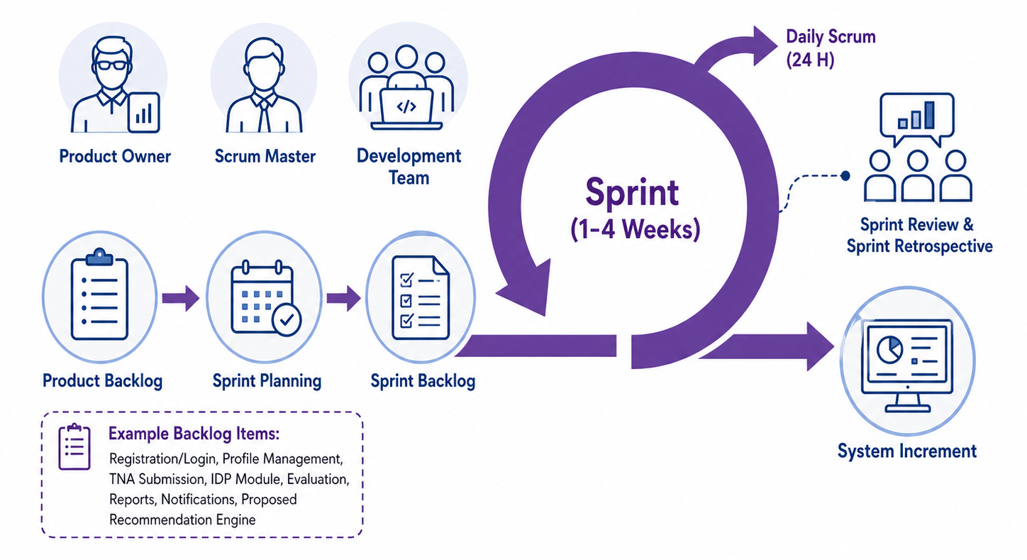

Figure 5. Agile Scrum Model

Product Backlog

The Product Backlog contains the list of features and requirements needed for the development and enhancement of TrainWise. The backlog was arranged according to priority, with the most important features listed first. Each item includes the estimated hours per day needed by the proponents to design, develop, test, and improve the feature.
Since TrainWise has different user roles, the Product Backlog was divided according to the main users of the system. This includes the backlog for regular users, HR Admin, Dean/Evaluator, and the recommendation engine. This arrangement allows the proponents to identify the specific functions needed by each role and properly prioritize the development of each module.
Table 3 presents the Product Backlog for Users. This table includes the main functions needed by faculty members and non-teaching personnel when using TrainWise. These features focus on user access, profile completion, Training Needs Assessment submission, Individual Development Plan creation, notifications, document generation, and the viewing of recommendation outputs.

Table 3. Product Backlog for Users
Priority | Features | Estimated hours per day
1 | As a user, I want to register and log in to the system using my assigned role. | 3 hrs
2 | As a user, I want to complete and update my profile information. | 4 hrs
3 | As a user, I want to submit my Training Needs Assessment form. | 5 hrs
4 | As a user, I want to enter my training history, desired skills, and comments. | 4 hrs
5 | As a user, I want to create and submit my Individual Development Plan. | 4 hrs
6 | As a user, I want to receive notifications and reminders about deadlines and system updates. | 3 hrs
7 | As a user, I want to view or generate printable TNA and IDP documents. | 4 hrs
8 | As a user, I want to view recommended training programs once the recommendation engine is integrated. | 4 hrs

Table 4 presents the Product Backlog for HR Admin. This table includes the administrative features needed to manage users, monitor submissions, set deadlines, generate reports, and maintain training-related records. The HR Admin serves as the main system controller; therefore, the features under this backlog focus on management, monitoring, documentation, and system administration.
Table 4. Product Backlog for HR Admin
Priority | Features | Estimated hours per day
1 | As an HR Admin, I want to approve or decline user registrations. | 3 hrs
2 | As an HR Admin, I want to manage user accounts and role-based access. | 4 hrs
3 | As an HR Admin, I want to set and manage TNA submission deadlines. | 3 hrs
4 | As an HR Admin, I want to monitor TNA submissions and IDP records. | 4 hrs
5 | As an HR Admin, I want to view employee training records and evaluation results. | 4 hrs
6 | As an HR Admin, I want to generate reports and export PDF documents. | 4 hrs
7 | As an HR Admin, I want to manage notifications and system announcements. | 3 hrs
8 | As an HR Admin, I want to manage training program records for future recommendation matching. | 4 hrs

Table 5 presents the Product Backlog for the Dean/Evaluator. This table focuses on the evaluation-related functions of TrainWise. Since the Dean or evaluator is responsible for reviewing employee submissions by department, the backlog includes access to department records, TNA review, evaluation, filtering, and viewing of evaluation summaries.
Table 5. Product Backlog for Dean/Evaluator
Priority | Features | Estimated hours per day
1 | As a Dean/Evaluator, I want to log in securely using my assigned account. | 2 hrs
2 | As a Dean/Evaluator, I want to view employee submissions by department. | 4 hrs
3 | As a Dean/Evaluator, I want to review Training Needs Assessment records. | 4 hrs
4 | As a Dean/Evaluator, I want to evaluate employee submissions. | 5 hrs
5 | As a Dean/Evaluator, I want to filter records by department, status, and employee type. | 4 hrs
6 | As a Dean/Evaluator, I want to view evaluation summaries for monitoring and documentation. | 4 hrs

Sprint Planning
As stated in the Sprint Backlog, selected items from the Product Backlog were moved into specific development tasks that the proponents planned to accomplish within each sprint. These tasks served as a guide in designing, coding, testing, and improving each module of TrainWise. The Sprint Backlog includes the feature to be developed, the specific task to be performed, and the estimated hours per day needed to complete each task.
Table 6 presents the Sprint Backlog for Users, which details the specific features and tasks selected for development during the sprint. These items served as the proponents’ guide in designing, coding, testing, and improving the user-side modules of TrainWise. The sprint backlog includes tasks for user registration, role-based access, profile management, Training Needs Assessment submission, Individual Development Plan creation, notifications, printable documents, and the interface for viewing recommendation results.

Table 6. Sprint Backlog for Users

Priority | Features | Task | Estimated hours per day
1 | User registration and login | Design and develop user registration, login validation, and session handling. | 3 hrs
2 | Role-based access | Create access control for Faculty and Non-Teaching Personnel users. | 3 hrs
3 | Profile management | Develop profile completion and update forms for employee information. | 4 hrs
4 | TNA submission | Design and develop the Training Needs Assessment form with validation. | 5 hrs
5 | Training history and desired skills | Store training history, desired skills, and comments in the database. | 4 hrs
6 | IDP creation | Design and develop the Individual Development Plan creation and submission module. | 4 hrs
7 | Notifications | Implement user notifications and reminders for deadlines and updates. | 3 hrs
8 | Printable documents | Develop PDF export for TNA and IDP documents. | 4 hrs
9 | Recommended training programs | Prepare the user interface for displaying future recommendation results. | 4 hrs
Table 7 shows the sprint backlog for the HR Admin side.
Table 7. Sprint Backlog for HR Admin
Priority | Features | Task | Estimated hours per day
1 | User approval | Develop approval and decline functions for newly registered users. | 3 hrs
2 | User management | Create user account management and role assignment functions. | 4 hrs
3 | Deadline management | Develop deadline setting and monitoring for TNA submissions. | 3 hrs
4 | Submission monitoring | Create monitoring functions for TNA submissions and IDP records. | 4 hrs
5 | Admin dashboard | Develop dashboard cards, summary counts, and administrative links. | 4 hrs
6 | Reports | Create report filtering, viewing, and monitoring functions. | 4 hrs
7 | PDF export | Develop PDF export for TNA, IDP, evaluation, and summary reports. | 4 hrs
8 | Notifications | Implement notification and announcement management for users. | 3 hrs
9 | Training program records | Prepare database structure for future training program records. | 4 hrs
10 | Recommendation result storage | Prepare proposed storage for recommendation results and similarity scores. | 5 hrs

Table 8 shows the sprint backlog for the Dean/Evaluator side.
Table 8. Sprint Backlog for Dean/Evaluator

Priority | Features | Task | Estimated hours per day
1 | Dean/Evaluator login | Design and develop secure login access for Dean/Evaluator accounts. | 2 hrs
2 | Department records | Develop a page for viewing employee submissions by department. | 4 hrs
3 | TNA review | Create a detailed view for reviewing Training Needs Assessment records. | 4 hrs
4 | Evaluation form | Develop department-based evaluation forms and rating submission. | 5 hrs
5 | Filtering | Add filtering by department, employee type, and submission status. | 4 hrs
6 | Evaluation summary | Create evaluation summary views for monitoring and documentation. | 4 hrs

Table 9 shows the sprint backlog for the recommendation engine preparation.
Table 9. Sprint Backlog for the Recommendation Engine

Priority | Features | Task | Estimated hours per day
1 | Data preparation | Identify employee profile, TNA, IDP, and evaluation fields needed for recommendation processing. | 5 hrs
2 | Training program dataset | Prepare the structure for training program names, categories, descriptions, and target competencies. | 4 hrs
3 | Python Recommendation API | Design the proposed API flow between the PHP-based TrainWise system and the Python recommendation service. | 5 hrs
4 | XGBoost processing | Prepare structured data features such as department, role, designation, years of service, and training history. | 6 hrs
5 | SBERT text matching | Prepare the process for comparing desired skills and comments with training program descriptions using semantic similarity. | 6 hrs
6 | Recommendation output | Prepare the planned interface and storage for recommendation results, similarity scores, and model outputs. | 5 hrs

Daily Scrum
The Daily Scrum was conducted to monitor the progress of the development activities. During this short meeting, the proponents discussed completed tasks, current development concerns, encountered errors, and the next tasks to be performed. This allowed the team to identify issues early and make necessary adjustments during the sprint.
For TrainWise, the Daily Scrum focused on checking the progress of user authentication, profile management, TNA submission, IDP creation, evaluation pages, report generation, database functions, interface design, and system testing. For the recommendation engine, Daily Scrum discussions covered data preparation, database enhancement, Python API development, XGBoost feature engineering, SBERT text matching, and recommendation result validation
Sprint Execution
Sprint Execution refers to the actual development of the tasks identified in the Sprint Backlog. During this phase, the proponents coded, tested, revised, and improved the selected system features. The existing TrainWise system was developed using PHP, MySQL/MariaDB, HTML, CSS, Tailwind CSS, JavaScript, and supporting tools for PDF generation and email notification.
For the recommendation engine, Sprint Execution involved building the Python-based Recommendation API, structured data processing using XGBoost, and textual similarity matching using Sentence-BERT.

Sprint Review
The Sprint Review was conducted at the end of each sprint to evaluate the completed features and determine whether they met the expected requirements. During this phase, the proponents reviewed the functionality of the system modules and identified possible improvements based on adviser, evaluator, and user feedback.
For the existing TrainWise system, Sprint Review involved checking the registration and login process, profile completion, TNA submission, IDP creation, evaluation module, notification feature, report generation, and PDF export. For the recommendation engine, the review focused on checking whether the data structure, API flow, model input requirements, and recommendation output design were appropriate for integration with the main system

Sprint Retrospective
The Sprint Retrospective was conducted after each Sprint Review to identify what went well, what problems occurred, and what improvements should be applied in the next sprint. This phase helped the proponents improve their development process, task distribution, coding practices, testing activities, and documentation.
In TrainWise, the Sprint Retrospective helped the proponents identify improvements related to user interface consistency, database structure, form validation, role-based access, report formatting, and usability.

System Increment and Deployment
At the end of each sprint, a working system increment was produced. Each increment represented a completed or improved part of TrainWise. These increments were tested and reviewed before being integrated into the main system.
The existing TrainWise system is deployed as a PHP and MySQL-based web application for use by LSPU Los Baños Campus. The recommendation engine was developed as a separate Python-based component and integrated through an API. This setup allows the main system to remain stable and independently testable while the machine learning process was developed, tested, and integrated.
Through Agile Scrum Methodology, the proponents were able to organize the development of TrainWise into manageable and measurable tasks. The use of Product Backlog, Sprint Planning, Sprint Backlog, Daily Scrum, Sprint Review, and Sprint Retrospective supported the systematic development of the existing system and the structured recommendation engine. This methodology is suitable for the project because TrainWise requires continuous improvement, user feedback, module-based testing, and integration of machine learning and Natural Language Processing features.

Project Testing and Evaluation
This section presents the testing and evaluation procedures conducted in fulfillment of the three specific objectives of the study. In accordance with the objectives, the testing procedures are organized to: (1) validate the design of the XGBoost and Natural Language Processing-based recommendation model through technical evaluation, covering model fit, recommendation relevance, and response time, detailed in Chapter 3; (2) verify the correctness and readiness of the enhanced TrainWise application, covering user registration, TNA form submission, IDP creation, evaluation management, report generation, notification delivery, and the training recommendation feature, through functional and non-functional software testing; and (3) formally evaluate the existing and enhanced system using the Technology Acceptance Model (TAM) and the ISO/IEC 25010 Software Quality Model in terms of usability, functionality, performance efficiency, and user acceptance. The software testing procedures described in this section apply to both the existing system modules and the now-integrated recommendation engine.
Furthermore, the evaluation process employs the ISO/IEC 25010 Software Quality Model and the Technology Acceptance Model (TAM) as evaluation frameworks. The ISO 25010 model assesses the system's product quality characteristics, while TAM measures perceived usefulness and ease of use among different user groups. The results of these evaluations serve as the basis for improving the system and determining its readiness for institutional deployment at Laguna State Polytechnic University (LSPU) Los Baños Campus.

Software Testing
Software testing ensures that each module and component of TrainWise is properly validated before deployment. The proponents are to conduct multiple levels of testing, functional and non-functional to confirm that the system performs as intended for all user roles: Faculty, , College Deans, and the Admin.

Figure 6 shows the project testing and evaluation of the system. The first phase of this system's development is unit testing, which verifies that the system is operational. This is followed by integration testing, which focuses on the system architecture's modules and includes four additional submodules: compatibility, performance, stress, and load testing. Then there is system testing, which verifies that the system is operating as intended, and finally acceptance testing, which tests the system after it has been implemented.
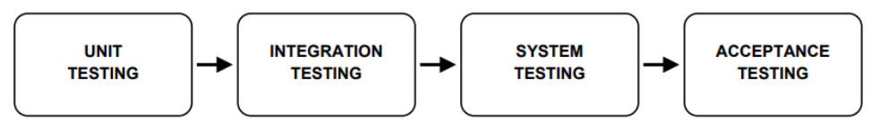
Figure 6. Levels of Software Testing
Unit Testing
Unit testing is the first level of software testing to be conducted during the development of TrainWise. In this phase, each individual module and component of the system is tested in isolation to verify that it functions correctly according to its intended design. The proponents test the core system modules including the User Registration and Login Module, TNA Form Module, IDP Module, Evaluation Module, Notification Module, Report Generation Module, and Training Recommendation Module independently before integrating them into the full system. Each module is subjected to test cases covering both valid and invalid inputs, boundary values, and expected system responses.
Test data consists of both simulated and actual records drawn from the TrainWise database, including valid and invalid credentials, sample TNA form entries, IDP records, and evaluation records. All test data are selected to represent both standard use cases and edge-case conditions such as missing fields, late submissions, and unauthorized access attempts.
Integration Testing
Integration testing is to be conducted after unit testing to verify that the individual modules of TrainWise work correctly when combined. This phase focuses on testing the interaction between modules, ensuring that data flows accurately from one component to another and that the integrated system produces the expected outputs.
The proponents follow the system's operational flow as the basis for integration test cases, beginning with user registration through to final report generation. For example, integration testing verifies that when a user submits a Training Needs Assessment form, the data is correctly captured, stored in the assessments table, and made visible to the assigned evaluator on their dashboard. Integration between the IDP module and the approval workflow is also tested to confirm that data flows correctly across all related database tables. Test data traces actual records across multiple linked database tables to verify referential integrity and status transitions throughout the approval workflow.
System Testing
System Testing is to be conducted after all individual modules have passed unit and integration testing. In this phase, the proponents assess the complete TrainWise system by simulating real-world usage scenarios to evaluate the system's end-to-end functionality, data integrity, and operational readiness. The objective is to verify that TrainWise performs as an integrated whole and meets all defined functional and non-functional requirements.
The proponents simulate complete workflow scenarios for each user role — employee, Unit Head, Dean/Evaluator, and Admin — and verify that the system handles edge cases, incorrect inputs, session management, and data consistency correctly. Error handling mechanisms are also tested to confirm that the system responds appropriately to unexpected inputs or network interruptions. Initial feedback gathered from test users during this phase is incorporated to further refine the system interface and functionality prior to formal user acceptance testing.
Acceptance Testing
Acceptance Testing is the final phase of software testing and is to be conducted to formally confirm that the system satisfies the agreed functional requirements and user expectations of its primary stakeholders: employees (faculty and staff), Unit Heads, College Deans, and the system administrator.
During acceptance testing, the proponents present the fully developed TrainWise system to the respondents under realistic operational conditions. Each user group is guided through the specific system functions relevant to their role, and respondents are asked to confirm whether each function performed as expected and whether the system addressed their actual work needs.
Evaluation Procedure
Standards such as ISO 25010, which outline the key aspects of product quality, are in place to ensure the quality of the system to be developed. The quality model regarded as the cornerstone of a system for evaluating product quality is described in the ISO 25010 standard. Eight quality characteristics that describe a software product's features for evaluation make up the ISO 25010 product quality model, as shown in Figure 7.
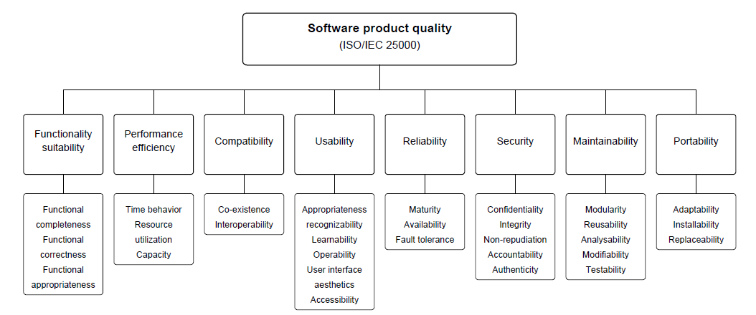

Figure 7. Quality Characteristics of ISO 25010
The respondents are the IT professionals, including developers and network engineers, evaluate the developed system using the ISO 25010 software standard to assess the performance and general features of TrainWise. The ISO 25010 model is the most widely used standard for determining the consistency and quality of any software program. Assessments include both functional and non-functional aspects, as well as internal and external design and structure.

For evaluating the system, the proponents conduct beta testing with IT professionals. The ISO 25010 quality model serves as the standard for the rating scale. The Functional Suitability, Performance Efficiency, Compatibility, Usability, Reliability, Security, Maintainability, and Portability are the basis for testing and evaluating TrainWise. The scale is answerable by five responses: Excellent (5), Good (4), Fair (3), Needs Improvement (2), and Poor (1).
Functional Suitability. One of the most important parts is software that must suit the goals and needs of the user. The proponents demonstrate that TrainWise correctly fulfills all user requirements — including TNA form submission, IDP creation, evaluation review, report generation, and notification delivery — to achieve acceptance of the solution as effective and efficient.
Performance Efficiency. Software execution is an important factor in selecting a product to use. The proponents assess whether TrainWise responds quickly to user interactions, processes form submissions without delay, and generates PDF reports and email notifications within acceptable time limits, representing the overall capability of the system.
Compatibility. The proponents ensure client satisfaction by verifying that TrainWise functions consistently across a variety of browsers (Google Chrome, Mozilla Firefox, Microsoft Edge), operating systems (Windows, macOS, Android, iOS), and device types (desktops, laptops, and smartphones).
Usability. The product's worth and utility are readily apparent to users. The proponents design TrainWise to be accessible and easy to navigate for all user roles — employees, Unit Heads, College Deans, and administrators — including users who may vary in their level of digital literacy.
Reliability. As part of evaluating quality through analysis and determining accuracy, IT experts examine the application's reliability in consistently saving data correctly, maintaining session integrity across concurrent users, and recovering gracefully from unexpected interruptions.
Security. The IT professional examines the application's data protection measures, including session management, role-based access control (RBAC), input validation and sanitization implemented through the sanitize_input() function, and compliance with data privacy regulations.
Maintainability. The IT professional examines the application's capacity to determine whether it can be efficiently updated, extended, or restructured over time, including how readily the now-integrated XGBoost-NLP recommendation engine can accommodate future enhancements such as real-time model retraining or an expanded training program catalog.
Portability. Ensures that the system's functionality can be transferred from one environment to another, such as from the current InfinityFree hosting environment to alternative servers with minimal modification to the PHP-MariaDB architecture.
Furthermore, initial testing is to be conducted by the developers during the development of TrainWise to discover and correct any flaws. The developers test every module and functionality using the created planned procedure to check and examine accuracy, reliability, efficiency, effectiveness, user-friendliness, and complete functionality — to determine whether the system achieves the desired features and requirements specified by employees and institutional stakeholders.
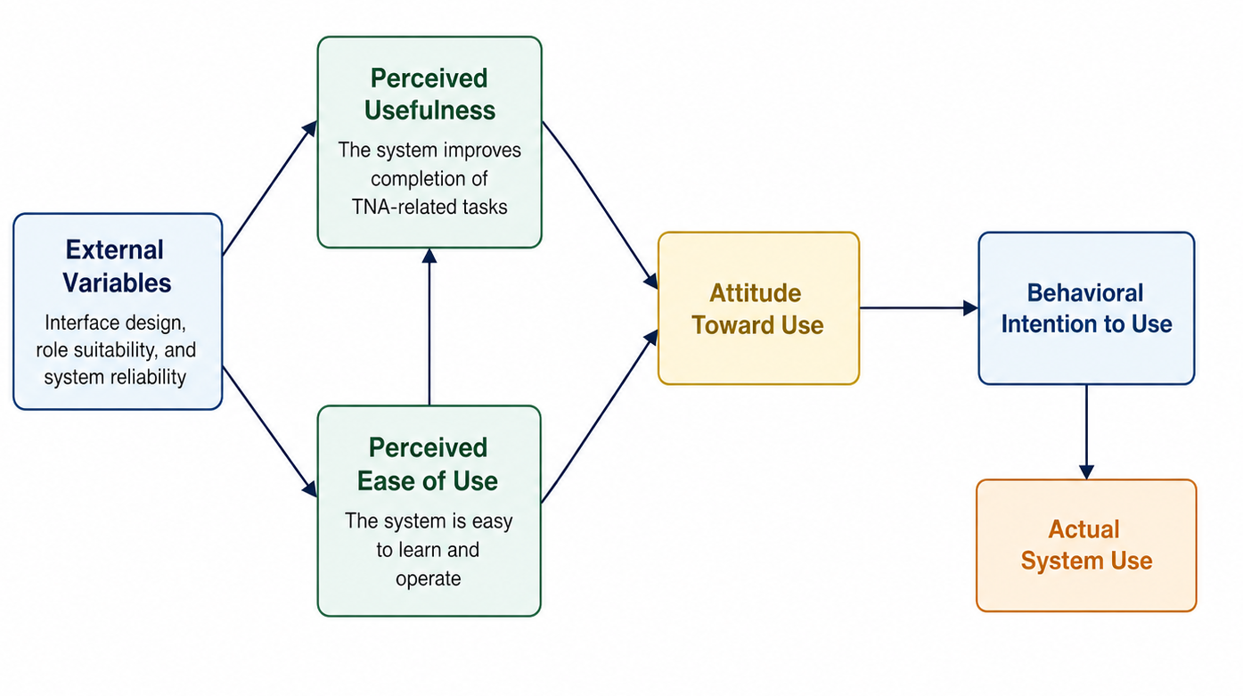
Technology Acceptance Model (TAM)

Figure 8. Quality Characteristics of the Technology Acceptance Model
The Technology Acceptance Model (TAM) is an information systems theory that explains how users come to accept and use a new technology. TAM highlights that actual system utilization, the point at which individuals actively use a technology and is influenced by several key factors. Traditionally, TAM identifies two primary factors that impact acceptance: (1) perceived usefulness, which reflects how beneficial the user believes the technology will be in enhancing their work performance; and (2) perceived ease of use, which represents how effortless they find the technology to operate. Additional factors also contribute to technology acceptance, including attitude toward use, which reflects the user's overall disposition toward adopting the system, and behavioral intention to use, which captures the user's plan to continue using the technology in their regular institutional work.

The model takes into account the user's readiness to integrate the technology into their daily tasks. Together, these factors shape the behavioral intention to use the technology, ultimately leading to actual system usage. This evaluation framework provides a structured way to identify and address barriers to adoption, ensuring that TrainWise meets the expectations and requirements of its users at LSPU Los Baños Campus. The TAM model also emphasizes iterative feedback, enabling the proponents to refine the system based on user perceptions and experiences. By understanding these dynamics, the proponents can prioritize features and functions that align with user needs, increasing the likelihood of successful institutional implementation and long-term utilization.

The proponents use the TAM framework to determine the extent to which TrainWise is easy to use and how each module is functional, reliable, and whether the system is genuinely useful to its teaching and non-teaching personnel. This research collects data and responses from the conducted survey. As a result, it is important to evaluate the effectiveness of the system as well as how user requirements such as interface design and system benefits are addressed.
Table 10. Four-Point Likert Scale for TAM Evaluation
Degree | Range | Description
4 | 3.26 – 4.00 | Strongly Acceptable
3 | 2.51 – 3.25 | Acceptable
2 | 1.76 – 2.50 | Not Acceptable
1 | 1.00 – 1.75 | Strongly Not Acceptable

For the XGBoost-NLP recommendation engine, an additional TAM dimension assesses users’ perceived usefulness and perceived ease of use of the automated training recommendation feature now integrated into TrainWise.

Evaluation of the Recommendation Engine

The XGBoost and Natural Language Processing-based training recommendation engine is implemented and integrated into TrainWise. Because sufficient labeled TNA data from actual system users was not yet available at the time of development, feature engineering was based on structured profile fields (department, designation, position, employment or teaching status, years in LSPU, and educational attainment), and XGBoost was trained on a synthetic, rule-based bootstrap dataset rather than organically accumulated labeled data, a deviation from the original plan that is documented and justified in the Data Annotation section of Chapter 3. Sentence-BERT (SBERT) is used for textual similarity matching between free text input and training program descriptions, and a Python-based RESTful API built with FastAPI serves recommendations to the TrainWise front end.
The recommendation engine's technical evaluation has been completed and is detailed in Chapter 3. The XGBoost component, implemented as a regressor rather than a classifier, was evaluated using Mean Absolute Error, Root Mean Squared Error, and R² on a held-out test split across all fourteen training categories, achieving an average R² of 0.8685. The SBERT component was evaluated using Top-1 and Top-3 accuracy and Mean Reciprocal Rank against a curated set of query-program pairs, achieving 89% Top-1 and 100% Top-3 accuracy. API response time was benchmarked under sequential and concurrent load, with a mean of 0.14 seconds and 0.92 seconds respectively, both well within the five-second target.
Two evaluation components remain pending at the time of this writing. First, a user evaluation survey will be administered to employees and Unit Heads to assess the perceived usefulness and ease of use of the recommendations through the TAM framework. Second, an additional ISO 25010 evaluation round will be conducted specifically targeting the recommendation module, focusing on Functional Suitability, Performance Efficiency, and Reliability as experienced by actual end users, which is distinct from the technical benchmarks already completed.
Table 11 outlines the evaluation metrics and approaches for the XGBoost-NLP recommendation engine. The Model Fit, Recommendation Relevance, and API Response Time rows reflect completed technical evaluation with achieved results, while the Perceived Us efulness, Perceived Ease of Use, Functional Suitability, and System Reliability rows remain pending the TAM and ISO 25010 evaluation rounds described above.
Table 11. Evaluation Framework for the Recommendation Engine
Evaluation Aspect | Component | Metric | Target | Result
Model Accuracy | XGBoost Regression | MAE, RMSE, R² on  held-out 20% test set | R² ≥ 0.80 average | Achieved, R² 0.92 average
Recommendation Relevance | SBERT Similarity Matching | Top-1 / Top-3 accuracy, Mean Reciprocal Rank against 18 curated query-program pairs | Top-3 ≥ 90% | Achieved, Top-1 89%, Top-3 100%
API Response Time | FastAPI /recommend Endpoint | Response time under sequential and concurrent load | < 5 seconds/request | Achieved — 0.14s seq. / 0.92s concurrent mean
Perceived Usefulness (TAM) | End-User Survey | 4-point Likert mean score | ≥ 3.26 (Strongly Agree) | Pending
Perceived Ease of Use (TAM) | End-User Survey | 4-point Likert mean score | ≥ 3.26 (Strongly Agree) | Pending
Attitude (TAM) | End-User Survey | 4-point Likert mean score | ≥ 3.26 (Strongly Agree) | Pending
Behavioral Intention (TAM) | End-User Survey | 4-point Likert mean score | ≥ 3.26 (Strongly Agree) | Pending
Functional Suitability (ISO 25010) | Beta Testing with Respondents | 5-point Likert mean score | ≥ 3.81 (Good) | Pending
System Reliability | IT Expert Review | 5-point Likert mean score | ≥ 3.81 (Good) | Pending

The proponents emphasize that Table 11 presents the evaluation framework for the recommendation engine. The Model Fit, Recommendation Relevance, and API Response Time rows have been completed with achieved results, while the TAM and ISO 25010 rows remain pending the respondent-based evaluation described in this chapter. This framework ensures that the machine learning component is evaluated rigorously

Population of the Study
The population of this study consists of the primary users and technical evaluators of the TrainWise system at Laguna State Polytechnic University (LSPU) Los Baños Campus. The respondents are categorized into three groups that represent the complete range of system interaction: employees (faculty and staff) as primary end-users of the TNA Form, IDP, and Notification modules; Unit Heads and College Deans as institutional evaluators who use the assessment review and approval workflow; and IT experts who evaluate the system's technical quality from a professional standpoint, including its architecture and the implemented recommendation component. These groups are selected because their combined perspectives, operational, administrative, and technical, ensure a comprehensive evaluation that is aligned with all three objectives of the study.
Table 12 presents the distribution of respondents involved in the testing and evaluation of TrainWise.
Table 12. Respondents of the Research Project
Category of Respondents | Sample Size
Teaching and Non-Teaching Personnel | 70
IT Professionals (Developers, Network Engineers) | 2
Total | 72

Sampling Design
The proponents employ purposive sampling as the primary sampling strategy for this study. This non-probability sampling technique is appropriate because the evaluation of TrainWise requires respondents who have direct, role-based experience with the system or possess the technical expertise necessary to assess its quality characteristics meaningfully. Respondents are selected from the LSPU Los Baños Campus community based on their designated role, as teaching or non-teaching personnel, or as IT professionals, rather than through random selection.
In addition, stratified sampling is applied to organize the selected respondents into two distinct subgroups corresponding to their user role: teaching and non-teaching personnel, and IT professionals (developers and network engineers). This stratification ensures that evaluation data is gathered from each relevant stakeholder group and that the analysis reflects role-specific perceptions of the system's usability, functionality, and technical quality. The combination of purposive and stratified sampling ensures that the study gathers targeted, representative, and contextually meaningful evaluation data from across the full spectrum of TrainWise users.

Data Collection Instrument
The proponents use structured questionnaire surveys as the primary data collection instruments, distributed to all respondents following the acceptance testing phase. Two sets of questionnaires are prepared and administered.

The first set is based on the Technology Acceptance Model (TAM) and measures user acceptance across four constructs: Perceived Usefulness, Perceived Ease of Use, Attitude Towards Using, and Behavioral Intention to Use. This questionnaire uses a 4-point scale with response options of Strongly Agree (4), Agree (3), Disagree (2), and Strongly Disagree (1), and is administered to teaching and non-teaching personnel with direct, role-based experience using TrainWise.

The second set is based on the ISO/IEC 25010 Software Quality Model and assesses the system's product quality across eight characteristics: Functional Suitability, Performance Efficiency, Compatibility, Usability, Reliability, Security, Maintainability, and Portability. This questionnaire uses a 5-point scale with response options of Excellent (5), Good (4), Fair (3), Needs Improvement (2), and Poor (1), and is administered exclusively to IT professionals (developers and network engineers), who are equipped with the technical background needed to assess all eight quality characteristics meaningfully.

Both questionnaires are made available in physical printed copies and as Google Form digital surveys to ensure accessibility for all respondents. Interview sessions are also conducted as supplementary instruments to gather qualitative insights on the system's usability, institutional relevance, and potential improvements. All instruments are reviewed for clarity, relevance, and appropriateness prior to distribution, and are aligned with the specific features and workflow of TrainWise

Statistical Analysis of Data

The data gathered from the evaluation instruments are analyzed using the following statistical methods. Frequency and Percentage Distribution. The frequency of each response option is tallied and converted to a percentage of the total number of respondents using the formula: % = (f / N) × 100, where f is the frequency of a given response and N is the total number of respondents. This allows the proponents to identify the distribution of responses across each evaluation item and determine which system characteristics are rated most and least favorably by respondents.
Weighted Mean. The weighted mean is computed for each evaluation item to derive a representative average score reflecting the collective rating of all respondents. For the ISO 25010 5-point scale, the formula is: x̄ = [(SA × 5) + (A × 4) + (N × 3) + (D × 2) + (SD × 1)] / N, where x̄ = Mean, N = Total number of respondents, SA = Strongly Agree, A = Agree, N = Neutral, D = Disagree, SD = Strongly Disagree. For the TAM 4-point scale, the formula is: x̄ = [(SA × 1) + (A × 2) + (D × 3) + (SD × 4)] / N, where SA = Strongly Agree, A = Agree, D = Disagree, SD = Strongly Disagree.
Cronbach's Alpha. To measure the internal consistency and reliability of the evaluation instruments, the proponents compute Cronbach's alpha for each TAM dimension. A Cronbach's alpha value of 0.70 or above is considered acceptable for research instruments. Stratified Analysis. The proponents analyze evaluation results by respondent group — teaching and non-teaching personnel, and IT professionals — to identify differences in perceptions across user roles. The mean scores are interpreted using the descriptive ranges in Tables 13 and 14.
Table 13. Evaluation Degree, Range, and Description for ISO 25010
Degree | Range | Description
5 | 4.21 – 5.00 | Strongly Agree
4 | 3.81 – 4.20 | Agree
3 | 2.61 – 3.80 | Neutral
2 | 1.81 – 2.60 | Disagree
1 | 1.00 – 1.80 | Strongly Disagree

Table 14. Evaluation Degree, Range, and Description for TAM
Degree | Range | Description
4 | 3.26 – 4.00 | Strongly Acceptable
3 | 2.51 – 3.25 | Acceptable
2 | 1.76 – 2.50 | Not Acceptable
1 | 1.00 – 1.75 | Strongly Not Acceptable

Ethical Consideration
In the development, testing, and evaluation of TrainWise, the proponents are committed to upholding the highest standards of ethical research practice. Given that the system processes sensitive institutional data — including employee training histories, competency assessments, individual development plans, and departmental evaluation records — the protection of respondents' privacy, dignity, and data rights is treated as a fundamental obligation throughout the study.
Informed Consent. Prior to any data collection activity, all respondents are provided with a clear explanation of the study's purpose, the scope of their participation, and how their data will be used. Informed consent forms written in plain, accessible language are distributed and obtained from each respondent before they participate in testing or complete any evaluation questionnaire. Respondents are explicitly informed that participation is entirely voluntary and that they may withdraw at any time without consequence.

Confidentiality and Data Privacy. All personal information and evaluation data collected from respondents are treated with strict confidentiality. Individual responses are not disclosed to any unauthorized party and are used exclusively for evaluating and improving the TrainWise system. The study is conducted in full compliance with Republic Act No. 10173, or the Data Privacy Act of 2012, which governs the collection, processing, and protection of personal data in the Philippines. The role-based access control, session management, and input sanitization mechanisms built into TrainWise further ensure that employee records stored in the system are accessible only to authorized users.

Anonymity. Where applicable, individual responses are anonymized during data analysis so that no specific respondent can be identified from the reported results. Aggregate mean scores and percentage distributions are used in presenting evaluation outcomes, and no personal identifiers are included in the final research document.

Fairness and Non-Discrimination. All respondents are treated equitably throughout the evaluation process. Evaluation instruments are designed to be free of leading or biased questions, and all respondent groups are given equal opportunity to assess the system without coercion or undue influence.

Integrity of the Research Process. The proponents maintain transparency and academic integrity in all phases of the study. The XGBoost and SBERT components of the recommendation engine have been implemented and evaluated using held-out technical test data, with results reported accurately and traceably in this study. Perceived Usefulness, Perceived Ease of Use, and ISO 25010-based end-user evaluation remain pending and are clearly identified as such, to avoid any misrepresentation to the panel, the institution, or future readers of this study.

All collected evaluation forms and digital survey responses are stored securely and are accessible only to the research team. Digital data are retained only for the duration necessary to complete the study and are disposed of properly thereafter, in accordance with ethical and institutional data handling standards.

CHAPTER IV
RESULT AND DISCUSSION
This chapter showcases the findings and the discussion to support the methodology applied in reaching the objectives. The presentation is typically directed by the particular objectives or problem of the research study.
Results by Objectives of the Study
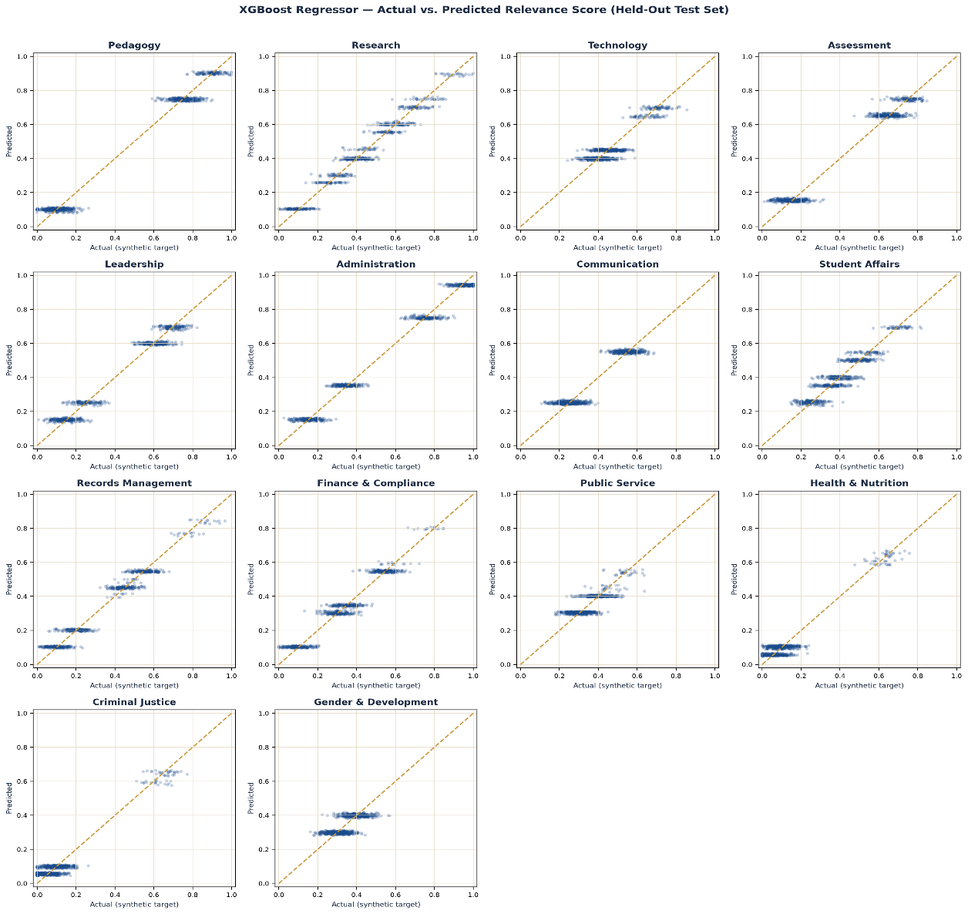
1. Develop a predictive recommendation model that uses XGBoost and Natural Language Processing (NLP) to go through employee data, surface possible competency gaps, and figure out the appropriate training needs based on both structured and unstructured inputs.

Figure 9. XGBoost Regressor — Actual vs. Predicted Relevance Score

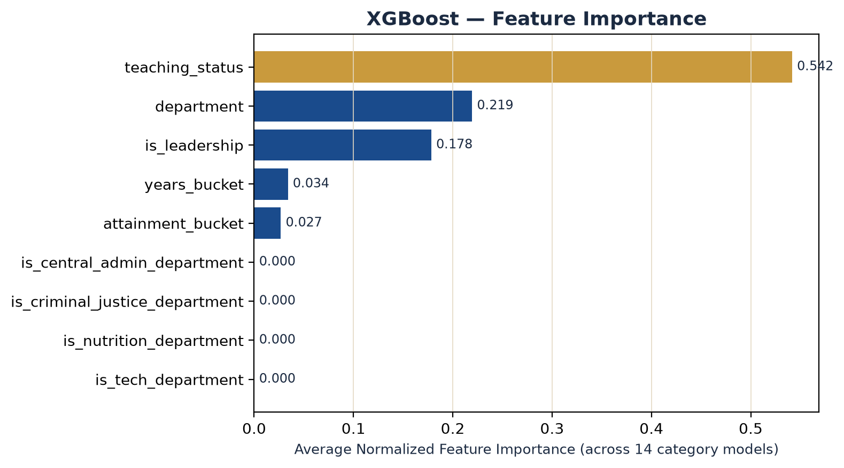
Figure 9 shows the actual-versus-predicted relevance scores for each of the eight XGBoost category regressors on the held-out 20% test set — data the models never saw during training or hyperparameter selection. Each point represents one test example; the dashed diagonal line marks a perfect prediction. Across all eight categories, predicted values cluster tightly along the diagonal in distinct horizontal bands, reflecting the discrete rule-based structure of the synthetic training targets. Pedagogy and Administration show the closest alignment to the diagonal, while Public Service and Gender and Development show visibly wider spread, consistent with their lower R² values reported in Table 15.

Figure 10. XGBoost — Feature Importance
Figure 10 shows the average normalized feature importance across all eight category regressors. Employment/teaching status remains the dominant factor in the model's decisions, now accounting for 54.2% of total importance, followed by department (21.9%) and leadership status (17.8%), with years of service and educational attainment contributing smaller shares. Four engineered flags meant to flag technology-adjacent, food-and-nutrition-adjacent, criminal-justice-adjacent, and central-administration-adjacent departments each contributed 0.0% importance, meaning the model derives no additional value from any of them beyond what it already extracts from the raw department feature directly. This confirms, across four separate cases rather than one, that XGBoost's native categorical splitting is already capable of isolating a subject-specific department on its own, without needing a hand-engineered hint to do so.

Table 15. XGBoost Regressor Evaluation Metrics
Category | Best Hyperparameters | MAE | RMSE | R²
Pedagogy | n_estimators=100, depth=3, lr=0.05 | 0.0417 | 0.0524 | 0.9781
Research | n_estimators=100, depth=3, lr=0.05 | 0.0402 | 0.0496 | 0.9502
Technology | n_estimators=100, depth=3, lr=0.05 | 0.0416 | 0.0518 | 0.8000
Assessment | n_estimators=100, depth=3, lr=0.05 | 0.0413 | 0.0521 | 0.9634
Leadership | n_estimators=100, depth=3, lr=0.05 | 0.0400 | 0.0496 | 0.9572
Administration | n_estimators=100, depth=3, lr=0.05 | 0.0387 | 0.0481 | 0.9781
Communication | n_estimators=100, depth=3, lr=0.05 | 0.0401 | 0.0503 | 0.8985
Student Affairs | n_estimators=100, depth=3, lr=0.05 | 0.0412 | 0.0511 | 0.8568
Records Management | n_estimators=100, depth=3, lr=0.05 | 0.0371 | 0.0464 | 0.9524
Finance & Compliance | n_estimators=100, depth=3, lr=0.05 | 0.0390 | 0.0492 | 0.9287
Public Service | n_estimators=100, depth=3, lr=0.03 | 0.0412 | 0.0520 | 0.5984
Health & Nutrition | n_estimators=100, depth=3, lr=0.05 | 0.0378 | 0.0465 | 0.9019
Criminal Justice | n_estimators=100, depth=3, lr=0.05 | 0.0386 | 0.0467 | 0.9113
Gender & Development | n_estimators=100, depth=3, lr=0.05 | 0.0409 | 0.0512 | 0.4837
Average | - | 0.0400 | 0.0498 | 0.8685
Table 15 shows the evaluation metrics for the XGBoost structured-data component across all fourteen training categories, computed on a held-out 20 percent test split. The model achieved an average Mean Absolute Error of 0.0400 and Root Mean Squared Error of 0.0498 on a 0 to 1 scale, meaning predictions typically land within four to five percentage points of the target score. The average coefficient of determination was 0.8685, ranging from 0.4837 for Gender and Development to 0.9781 for Pedagogy and Administration. The two categories with the weaker fit, Public Service and Gender and Development, are both training areas that apply broadly across nearly every employee regardless of department or years of service, which limits how much a model built on department and tenure can differentiate one employee's need from another's within those two categories specifically. This is reported as an observed limitation of the current structured-data model rather than an error, and is a reasonable direction for further refinement once more organic usage data becomes available.

Table 16. SBERT Semantic Matching Evaluation
Metric | Value
Validation queries | 18 (one per catalog program)
Top-1 accuracy | 88.9% (16/18)
Top-3 accuracy | 100% (18/18)
Mean Reciprocal Rank | 0.944
Average similarity — correct match | 0.611

Table 16 shows the evaluation results for the SBERT text-similarity component, tested against 18 hand-curated queries, one paraphrased training request per catalog program, deliberately worded to avoid the target program's own title or key terms so that a correct result demonstrates genuine semantic matching rather than keyword overlap. The model correctly ranked the intended program first for 88.9% of queries and within the top three results for all 18 queries, with a Mean Reciprocal Rank of 0.944, indicating that even when the top result was not the exact expected match, the correct program was almost always ranked immediately adjacent to it.
The combined recommendation engine's response time was also benchmarked: across 20 sequential requests, mean response time was 0.14 seconds (maximum 0.27 seconds); under 10 simultaneous concurrent requests, mean response time was 0.92 seconds (maximum 1.23 seconds), both comfortably within the study's five-second target.

2. Design and develop a web-based application by integrating the recommendation model with automated TNA assessment, reporting, and recommendation functions.
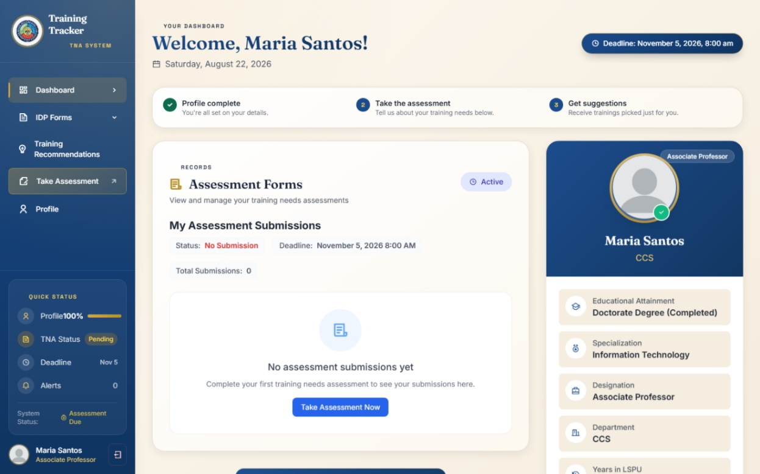

Figure 11. User Dashboard
Figure 11 shows the main dashboard presented to faculty and non-teaching personnel upon login. The dashboard displays the user's profile completion status, TNA submission status, upcoming deadline, and quick-access navigation to the Training Needs Assessment form, IDP Forms, Training Recommendations, and Profile modules. Before a profile is completed and an assessment submitted, the "Recommended For You" panel remains locked, guiding the user through the required sequence: complete profile, take the assessment, then receive recommendations.
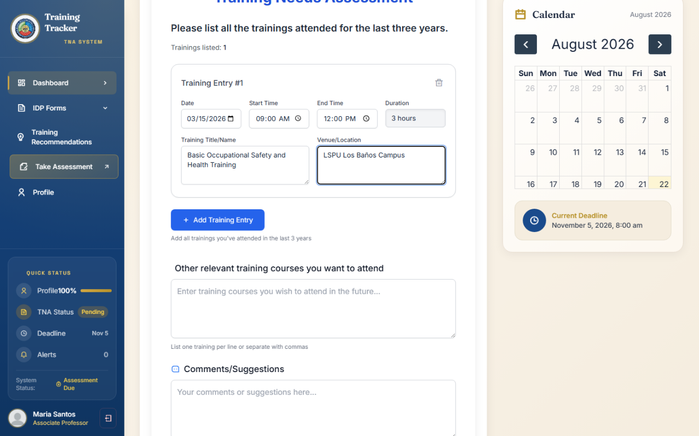

Figure 12. Training Needs Assessment Form
Figure 12 shows the Training Needs Assessment form, where users report trainings attended in the past three years including date, time, duration, title, and venue for each entry, alongside free-text fields for other training courses they wish to attend and additional comments or suggestions. These two free-text fields are the direct input to the SBERT semantic-matching component described in Chapter 3; the structured training-history entries and profile fields feed the XGBoost component.

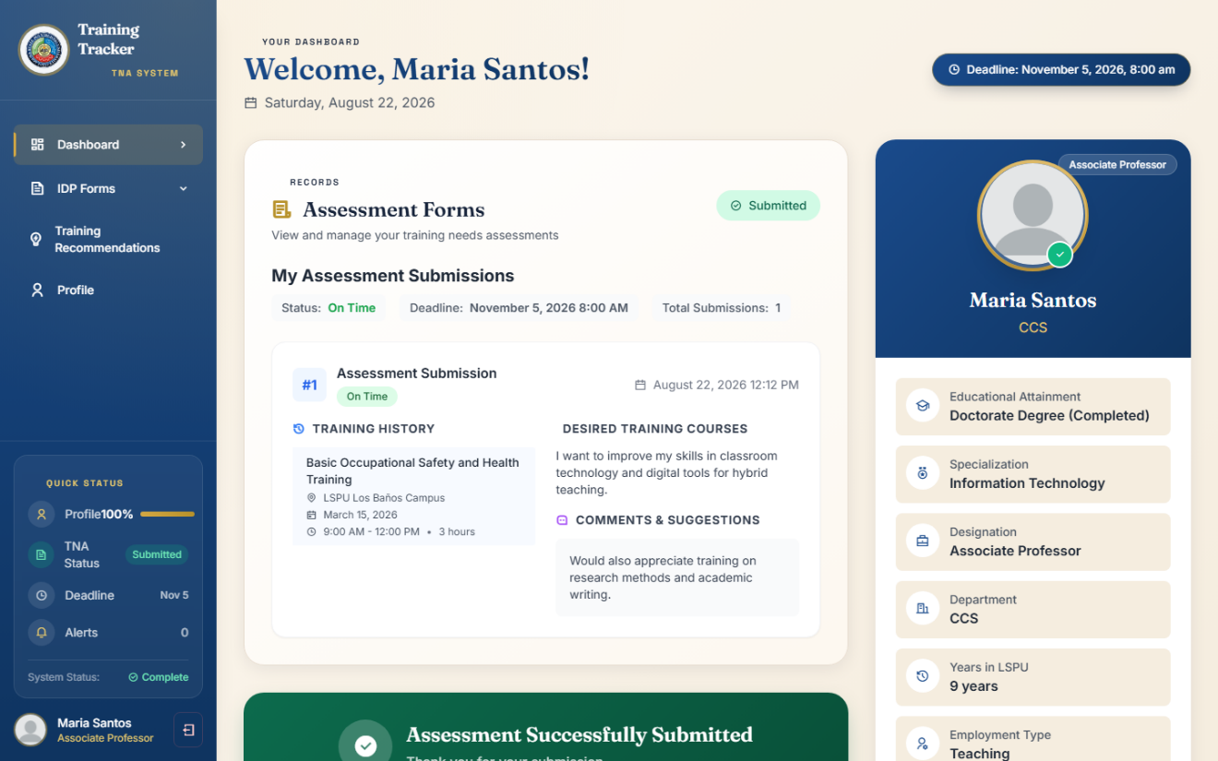

Figure 13. Assessment Submission Confirmation
Figure 13 shows the dashboard immediately after a Training Needs Assessment submission, displaying the recorded training history, desired training courses, and comments, along with a confirmation banner. Submission automatically triggers a refresh of the user's training recommendations, incorporating the newly submitted assessment data.



Figure 14. Recommended For You (Dashboard)

Figure 14 shows the "Recommended For You" panel that becomes available on the dashboard once both the profile and assessment requirements are met. Each recommendation card displays the training program title, a priority level (High/Medium/Low) derived from its rank in the combined XGBoost–SBERT score, and a short description drawn from the training program catalog.

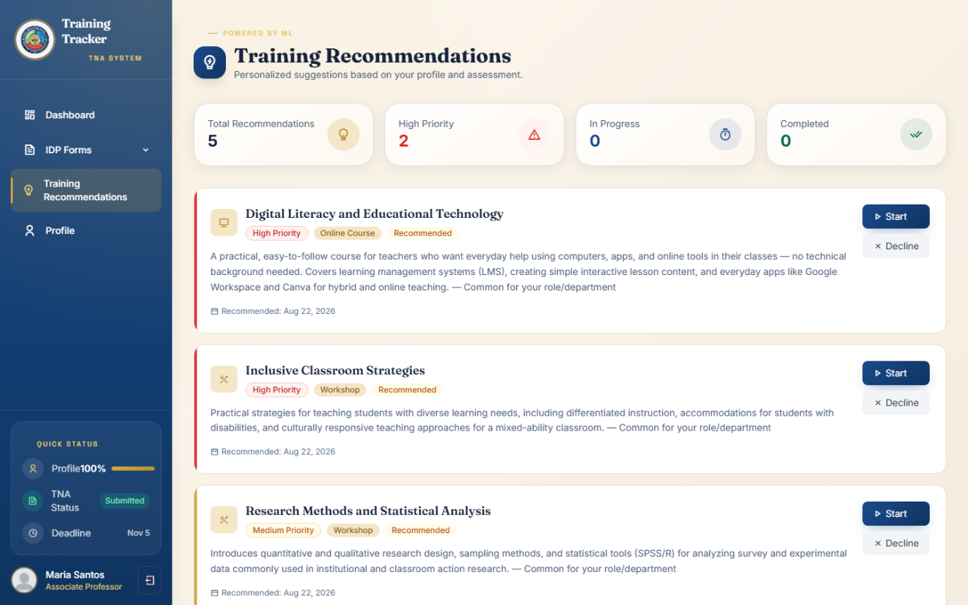
Figure 15. Training Recommendations Page

Figure 15 shows the dedicated Training Recommendations page, which presents the same recommendations in expanded form with summary counters and an option to accept or decline each one. Accepting a recommendation pools the employee's interest into the shared institutional demand described in Chapter 3, rather than immediately marking it in progress. The page also displays any training opportunity a college dean has posted directly for the employee's own college, which the employee may independently express interest in.

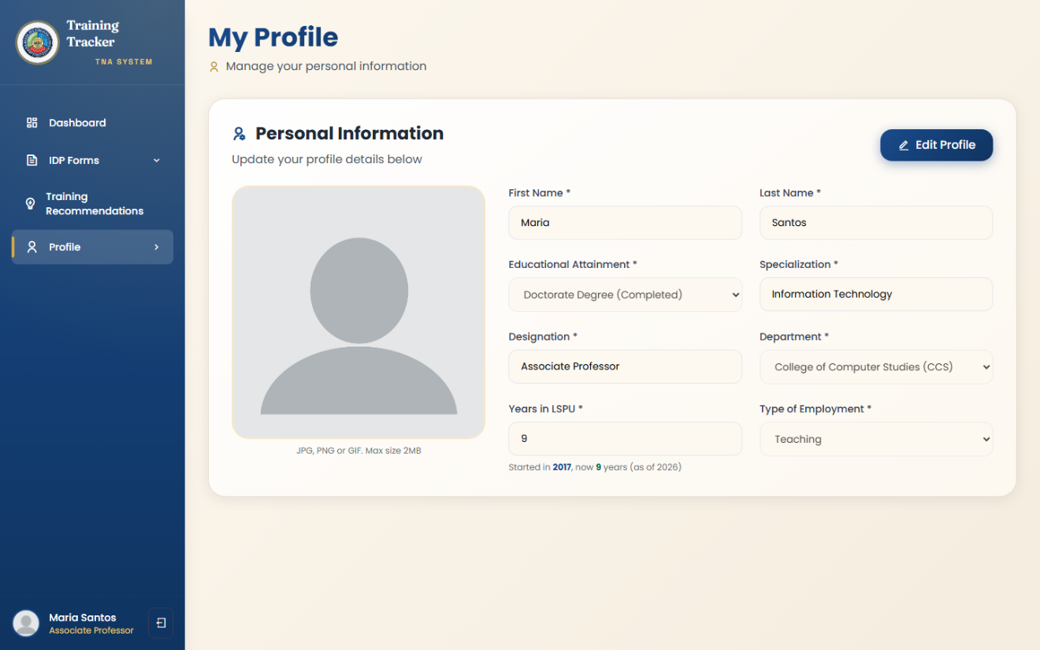
Figure 16. Profile Management
Figure 16 shows the Profile module, where users provide the structured fields: educational attainment, specialization, designation, department, years in LSPU, and employment type, that feed the XGBoost structured-data component. A completion indicator ensures users provide all fields required for the recommendation engine to function.

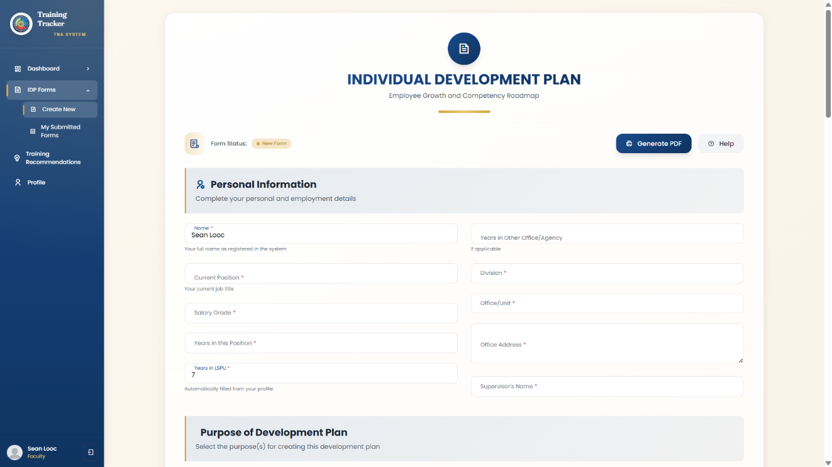

Figure 17. Individual Development Plan (IDP) Form
Figure 17 shows the Individual Development Plan module, where users document long-term and short-term development goals, training activities, and target completion dates, with digital signature support for employee, supervisor, and campus director certification.

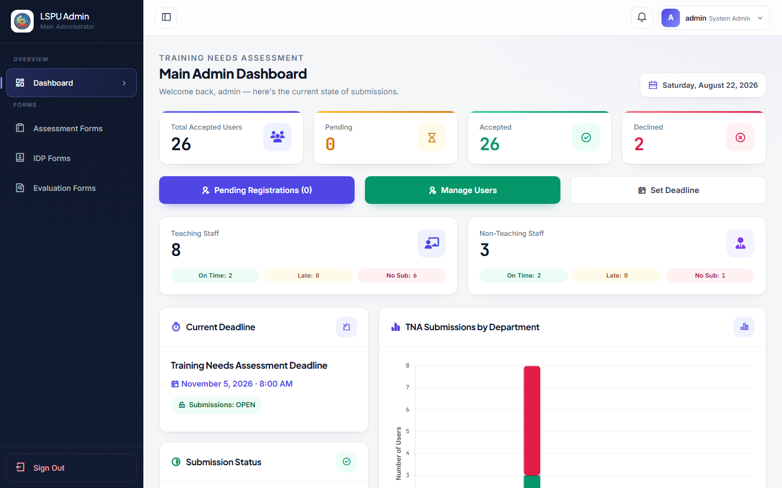
Figure 18. HR Admin Dashboard

Figure 18 shows the administrative dashboard used by HR Administrators to monitor system-wide TNA submission status, including total accepted users, submission counts broken down by teaching and non-teaching staff, and department-level submission tracking.

- Test and evaluate the existing and enhanced system using the Technology Acceptance Model (TAM) and ISO/IEC 25010 Software Quality Model in terms of usability, functionality, performance efficiency, and user acceptance.

Evaluation Result using TAM and ISO 25010
The results presented in this section are pending collection from the respondents identified in Table 17: 70 Teaching and Non-Teaching Personnel for the TAM evaluation, and 10 IT professionals for the ISO 25010 evaluation
Table 17 Explanation//
Table 17. Perceived Usefulness
Perceived Usefulness (PU) | Mean | SD | Interpretation
1. TrainWise helps me identify my training needs more effectively than manual assessment methods.
2. The system's training recommendations are relevant to my role and professional development.
3. TrainWise makes it easier to track my Training Needs Assessment submissions and status.
4. Using TrainWise reduces the time and effort needed to identify appropriate training programs.
5. Overall, TrainWise is a useful tool for managing my professional development needs.
COMPOSITE MEAN
n=70, Legend: highest to lowest as follows: four (4) – Strongly Agree (3.26 – 4.00), three (3) – Agree (2.51 – 3.25), two (2) – Disagree (1.76 – 2.50), and one (1) – Strongly Disagree (1.0 – 1.75)

Table 18 Explanation//
Table 18. Perceived Ease-of-Use

Perceived Ease-of-Use (PEU) | Mean | SD | Interpretation
1. The TrainWise interface is user-friendly and easy to navigate.
2. It is easy to complete my profile and submit a Training Needs Assessment form.
3. The training recommendations are presented in a clear and easy-to-understand manner.
4. I can easily find the features I need (assessment, recommendations, IDP) without assistance.
5. Overall, TrainWise is easy to use.
COMPOSITE MEAN
n=70, Legend: highest to lowest as follows: four (4) – Strongly Agree (3.26 – 4.00), three (3) – Agree (2.51 – 3.25), two (2) – Disagree (1.76 – 2.50), and one (1) – Strongly Disagree (1.0 – 1.75)

Table 19 Explanation//
Table 19. Attitude

Attitude (Towards Using the System) | Mean | SD | Interpretation
1. I feel positive about using TrainWise for my training needs assessment.
2. TrainWise fits well with how I want to manage my professional development.
3. I believe TrainWise can genuinely help improve training decisions at LSPU.
4. Using TrainWise is a worthwhile experience.
5. I would recommend TrainWise to my colleagues.
COMPOSITE MEAN
n=70, Legend: highest to lowest as follows: four (4) – Strongly Agree (3.26 – 4.00), three (3) – Agree (2.51 – 3.25), two (2) – Disagree (1.76 – 2.50), and one (1) – Strongly Disagree (1.0 – 1.75)

Table 20 Explanation//

Table 20. Behavior

Behavior (Intention to Use the System) | Mean | SD | Interpretation
1. I intend to use TrainWise regularly for future training needs assessments.
2. I am likely to rely on TrainWise's recommendations when choosing trainings to attend.
3. I am willing to continue using TrainWise for my Individual Development Plan.
4. I will recommend TrainWise to other faculty and staff.
5. I plan to continue using TrainWise once it is fully implemented institution-wide.
COMPOSITE MEAN
n=70, Legend: highest to lowest as follows: four (4) – Strongly Agree (3.26 – 4.00), three (3) – Agree (2.51 – 3.25), two (2) – Disagree (1.76 – 2.50), and one (1) – Strongly Disagree (1.0 – 1.75)
Table 21 Explanation
Table 21. Post Evaluation Result
Characteristics | Mean | SD | Interpretation
Functional Suitability
Performance Efficiency
Compatibility
Usability
Reliability
Security
Maintainability
Portability
Overall Mean

System and Software Testing Results

This section presents the results of software testing conducted on the enhanced TrainWise system, following the four levels of testing described in Chapter 3: Unit Testing, Integration Testing (including its compatibility, performance, and stress testing sub-modules), System Testing, and Acceptance Testing.

- Unit Testing

Unit testing was the first level of testing conducted for the enhanced TrainWise system. In this stage, each individual module was tested on its own, separate from the rest of the system, to check if it worked the way it was supposed to before being combined with other modules. The core modules tested included the Login and Registration Module, the IDP Module, the Notification Module, and the Report Generation Module, along with the access-control checks that protect every page from being viewed without logging in. Each module was tested using both valid and invalid inputs to observe how the system responded in different situations.

Table 22. Unit Test Results
Test ID | Steps | Expected Result | Actual Result | Remarks
UT-01 | Log in with a valid, accepted admin account | Redirect to admin_page.php | Redirected to admin_page.php | Passed
UT-02 | Log in with a valid, accepted faculty account | Redirect to user_page.php | Redirected to user_page.php | Passed
UT-03 | Log in with an unregistered email | Rejected, redirected to index.php with error | Redirected to index.php, error message present | Passed
UT-04 | Log in with a 'pending' status account | Rejected with pending-approval message | Redirected to index.php | Passed
UT-05 | Log in with a 'declined' status account | Rejected with declined message | Redirected to index.php | Passed
UT-06 | Request 4 protected pages (Dashboard, Admin, Training Recommendations, Profile) with no session | Redirect to index.php | All 4 redirected to index.php | Passed
UT-07 | Access IDP module as a logged-in user | Form loads (HTTP 200) | HTTP 200, form heading present | Passed
UT-08 | Mark notifications read with active session | {"success":true} | {"success":true} | Passed
UT-09 | Mark notifications read with no session | {"success":false} | {"success":false,"error":"Invalid request"} | Passed
UT-10 | Request report generation with no session | Redirect, no error exposed | Initially: fatal PHP error, stack trace exposed → Fixed → Redirected to index.php | Passed  after fix)
UT-11 | Request report generation as HR Admin | Valid PDF returned | Content-Type: application/pdf, 2266 bytes, valid PDF signature | Passed  after fix)
UT-12 | Request report generation as a non-admin faculty user | Access denied | Redirected to index.php | Passed

Table 22 shows the results of unit testing across seven core modules identified in Chapter 3: Registration/Login, IDP, Notification, Report Generation, and access control across all protected pages. Twelve of twelve test cases passed. One genuine defect was found and corrected during this phase: the Report Generation Module (generate_summary.php) connected to a hardcoded, non-existent database name and had no session or role check, causing it to throw an unhandled PHP fatal error — with a full file-path stack trace — to any visitor, authenticated or not. This was corrected to use the application's actual database connection and to restrict access to the HR Administrator role only, consistent with the access pattern already used elsewhere in the system. After the fix, the module was re-tested and correctly returns a valid PDF to authorized administrators (UT-11) while redirecting unauthorized and unauthenticated requests without exposing any error detail (UT-10, UT-12).
- Integration Testing
Integration testing was done after unit testing to check if the different modules of TrainWise worked well together. The goal was to make sure that data moved correctly from one part of the system to another and stayed consistent once several modules were combined. The actual operational flow of the system was used as the basis for these tests, starting from when a user submits a Training Needs Assessment all the way to when that data appears in the report generated by the HR Administrator. The training recommendation feature was also tested to check whether updating a recommendation's status was properly saved to the database and correctly reflected back on the page.

Table 23. Integration Test Results
Test ID | Steps | Expected Result | Actual Result | Remarks
IT-01 | Faculty submits TNA → stored in assessments table → included in HR Admin's generated report | Submission recorded and reflected in admin report | 1 row recorded for test user; admin PDF generated successfully | Passed
IT-02 | Accept a recommendation → interest pooled into shared institutional demand | Status updates to Accepted; a shared demand record is created or updated | Confirmed in the database and reflected on the Training Recommendations page | Passed
IT-03 | Attempt to mark a confirmed training complete without submitting proof of attendance | Action is rejected | Rejected, with a specific message identifying the missing document(s) | Passed
IT-03a | Submit all required proof of attendance, then mark the training complete | Status updates to Completed and a permanent record is added to the employee's training history | Confirmed: status updated, and the corresponding history record was created with the correct hours and date | Passed
IT-04 | Reload recommendations page after completing an item | Completed item is preserved, not overwritten by next ML refresh | Status remained 'Completed' after reload | Passed

Table 23 shows integration testing results tracing data across the assessment submission, reporting, and recommendation-tracking workflows. All four test cases passed, confirming that data flows correctly from the TNA form through to the assessments table and the HR Administrator's cross-institution report, and that user actions on training recommendations (Accept, Decline, and Complete, the last of which now requires proof of attendance) persist correctly and are not lost when the recommendation engine re-evaluates a user's suggestions after a new assessment submission — verifying the "preserve in-progress/completed items" design decision documented in Chapter 3
C. Compatibility Testing

As part of integration testing, compatibility testing was also conducted to check if TrainWise works consistently across different browsers, since faculty and staff may access the system using whichever browser they already have installed on their own devices. TrainWise was tested using three different browser engines representing the browsers most commonly used by end users: Chromium, which covers Google Chrome, Microsoft Edge, and Brave; Firefox; and Safari. Each engine was checked to confirm that login, the dashboard, and the Training Recommendations page all loaded and functioned correctly without errors.
Table 24. Cross-Engine Compatibility Testing

Browser Engine | Login | Dashboard Render | Recommendations Page | Console Errors | Remarks
Chromium (Chrome/Edge/Brave) | Passed | Passed | Passed | 0 | Passed
Gecko (Firefox) | Passed | Passed | Passed | 0 | Passed
WebKit (Safari) | Passed | Passed | Passed | 0 | Passed

Table 24 shows compatibility testing results across the three major browser rendering engines. Login, dashboard rendering, and the ML-powered Training Recommendations page were verified on each engine with zero JavaScript console errors, confirming consistent functionality and design across Chromium-based browsers (which cover Chrome, Edge, and Brave), Firefox, and Safari.

D. Stress Testing
Stress testing was performed, also as part of integration testing, to check how TrainWise behaves when many users use the system at the same time. This matters because LSPU Los Baños has a large number of faculty and staff who may access the system within the same window, especially as a submission deadline approaches. Apache Bench (ab) was used to simulate multiple users sending requests simultaneously, targeting the login process, the ML-integrated Training Recommendations page, and the recommendation status-update feature under different levels of concurrent load.

Table 25. Stress Test Results

Test ID | Steps | Expected Result | Actual Result | Remarks
ST-01 | 50 concurrent users, 2,000 login requests | 0% error rate, stable response time | Throughput: 592.88 req/sec, 0 failed requests, median 62ms, max 1,860ms | Passed
ST-02 | 30 concurrent users, 500 requests to the authenticated Training Recommendations page | 0% error rate | Throughput: 42.17 req/sec, 0 failed requests, median 715ms | Passed
ST-03 | 20 concurrent users, 200 requests updating a recommendation's status | 0% error rate | Throughput: 60.28 req/sec, 0 failed requests, median 326ms | Passed

Table 25 shows the results of stress testing conducted using Apache Bench (ab) against the login endpoint, the ML-integrated Training Recommendations page, and the recommendation status-update endpoint. All three tests completed with a 0% error rate. The login endpoint sustained 592.88 requests per second under 50 concurrent users. The Training Recommendations page — which performs several database lookups and a staleness check against the recommendation engine on every load — showed a higher but stable median response time of 715ms under 30 concurrent users, well within acceptable limits for a page that is not requested at high frequency in normal use. The status-update endpoint handled 20 concurrent write operations with a median response time of 326ms and no failed or lost updates, confirming the system remains stable and consistent under concurrent write load.

E. System Testing

System testing was conducted after the individual modules passed both unit and integration testing. In this phase, TrainWise was tested as a complete system rather than as individual modules, to check whether the system worked correctly as a whole from a real user's point of view. Complete workflows were simulated for the system's different user roles: employees, department Deans, and the HR Administrator, and the system was checked for how it handled situations such as invalid or expired sessions, incorrect input values, and attempts by a user to access data that does not belong to them.

Table 26. System Test Results
Test ID | Steps | Expected Result | Actual Result | Remarks
SYS-01 | Log in as a CCS department Dean (admin_ccs) | Redirect to the correct department dashboard | Redirected to CCS_admin/CCS.php, page rendered | Passed
SYS-02 | Inspect the Dean's dashboard for cross-department data leakage | Only CCS department data visible | No other department's data present on the page | Passed
SYS-03 | Request a protected page with a garbage/expired session cookie | Treated as unauthenticated, redirected to login | Redirected to index.php | Passed
SYS-04 | Submit an invalid status value to the recommendation-update endpoint | Rejected, no state change | {"success":false}, status unchanged | Passed
SYS-05 | Attempt to update another user's recommendation by guessing its ID | Update blocked; other user's data untouched | Target row unchanged (see note below) | Passed
SYS-06 | Complete continuous session: login → Dashboard → Profile → Recommendations → IDP | All pages load with consistent user identity throughout | All HTTP 200, identity consistent across all pages | Passed
SYS-07 | Attempt to forward a training request made up entirely of employees from offices with no assigned dean | Request is rejected by the system itself, not only hidden from view | Rejected, with a message directing Human Resource personnel to handle it directly | Passed

Table 26 shows System Testing results verifying complete, whole-system behavior beyond individual module interactions: role-based routing and data isolation for department-level administrators, session validity handling, input validation at the system boundary, cross-user authorization, and consistency across a full continuous user session. All six test cases passed. One implementation detail worth noting: in SYS-05, the update-authorization boundary correctly held — the SQL query scopes every update to the requesting user's own user_id, so no cross-user modification occurred — but the endpoint's JSON response reports success:true even when zero rows matched, since it does not currently distinguish "record updated" from "no matching record for this user." This does not constitute a security gap, as unauthorized writes are still prevented at the data layer, but is noted here as a minor response-accuracy improvement for future work.
F. Acceptance Testing
Acceptance Testing, as defined in Chapter 3, is conducted concurrently with the Technology Acceptance Model (TAM) and ISO/IEC 25010 evaluation round described in the next section, where the fully developed system is presented to employees, Unit Heads, College Deans, and IT experts under realistic operational conditions. Results are reported in Tables [TAM/ISO tables] once that testing round is complete.

